 **Westfield URC**

**Weekly Notice Sheet**

**for 4th October 2020 Harvest**

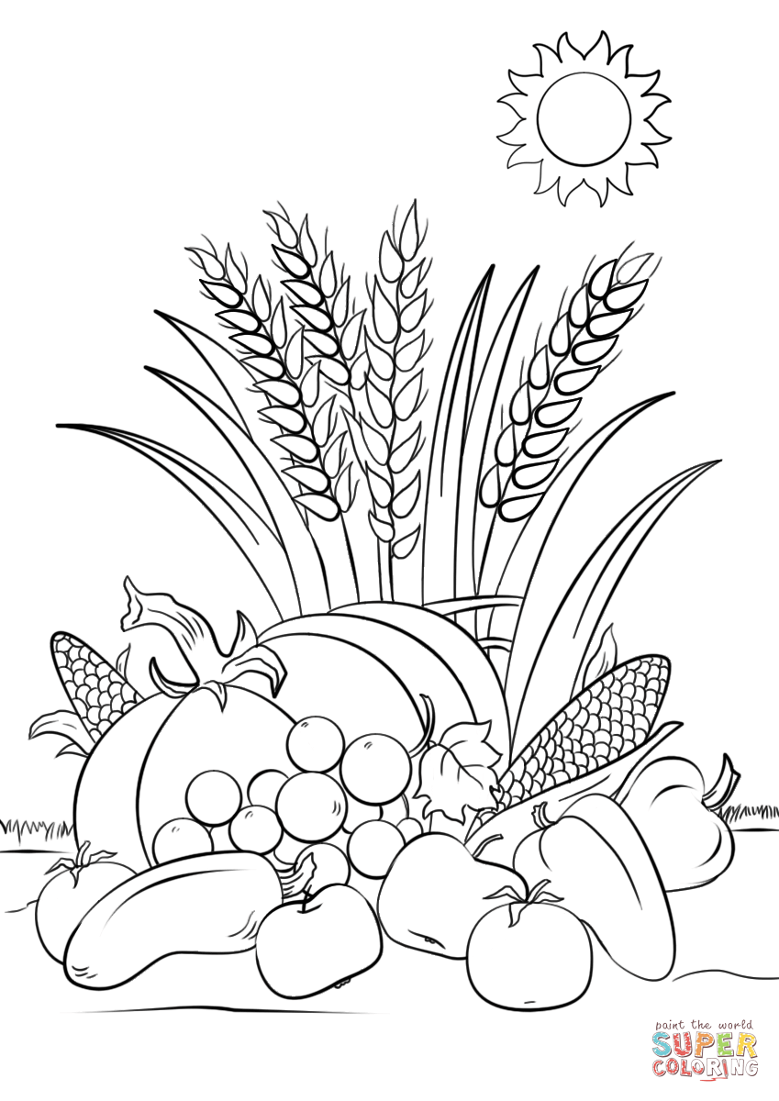

Praise God for

His harvest

**October / November newsletters are now available. Still if you have anything you want to share with the fellowship week by week please email it to Kath by Tuesday evening or ring and we will try to include it on the next weekly sheet.**

**Secretary: Kath Lonsdale: 01274 315203; 07759525936**

[**kathlonsdale@talktalk.net**](mailto:kathlonsdale@talktalk.net)

**Treasurer: Marjorie Hunt: 01274 677115**

**Westfield elders invite you to use the readings, prayers and reflections at 10.30am Sunday morning, if you are unable to be in church, to help us worship together in Spirit. This week Andrew and Kath lead our Harvest service and Neil leads our evening service.**

**Advanced notices**

Sunday 4th October 6.30pm evening service Neil

Tuesday 6th 7pm Bible study Romans part 2

Wednesday 7th 2pm Bible study Romans part 2

Sunday 11th October 9.30am Prayers

10.30am morning service

including communion Robin

**Thankyou for all your contributions for the Wyke food bank and for commitment for life.**

**Please pray** for the volunteers helping to safely reopen Wyke food bank this week. Please pray for all the clients as both get used to a restricted but Covid safe way of working.

**Please pray** for the Wyke schools as they get used to a different way of teaching and learning. Pray for all members of each school community.

|  |  |  |  |  |
| --- | --- | --- | --- | --- |
|  |  |  |  |  |

**I**

**Happy Birthday Sheila ( W ),**

**Muriel and Andrew**

**from your Westfield friends**



**Basil’s memories (11)**

On the 4th September 2005 my brother and I set off on another galavant. We drove to Hull and parked the car in a secure yard and went aboard the cruise ship Funchal, a former Portuguese royal barge. We made ourselves comfortable and found our way around the ship, and we were off. Our route was across the North Sea to the Skagarrat and down the Kattegat to Denmark. Our first call – Copenhagen. A lovely and lively city with royalty right in the middle. Of course we had to make our way to the Little Mermaid of Hans Anderson fame. We didn’t fancy or have time for the Tivoli Gardens (a popular action packed area like Blackpool pleasure beach).

Following an overnight sail we woke up in Sweden’s capital Stockholm, where we chose to visit the resurrected warship VASA sunk on its maiden voyage in 1628 having sailed about 100 yards. It was found and raised in the 1960’s. Very interesting but brief. Again it was overnight sailing and then we were in Finland – the home of the composer Jean Sibelius who wrote Finlandia. The capital Helsinki is renowned for the royal palace guards who do their regular drill looking like Olympic gymnastic floor routines in slow time. They contort themselves into all shapes and do it together. This is the land of 1000 lakes with daylight and night time each lasting 3 months. A strange little country but now part of the EU with a very noisy representative!! A most interesting market square offering some indefinable sweet meats. We didn’t have long to stay but it was quite unique. Then to Russia, St. Petersburg in particular. What an eye opener. Huge squares and even more huge the main highways. It must take all of 10 minutes just to walk across the main prospeck or street even without traffic. Of course no one knew where we were and all the signs were in Russian Cyrillic letters JLKJTRH, like that. We did get together for a splendid Russian meal including vodka by the gallon it seemed (for some) and then off to the ballet. Here the advantage was that all the action including dancing had a background of music alone. It really was very good and most enjoyable. There is so much to see in the city as well as the preserved evidence of the 900 days siege under constant Nazi bombardment. The welcome everywhere was warm and friendly even though there is not much English. Our two day stay in St Petersburg was certainly worthwhile. Back to the sea legs!

*B.P.H*

Westfield's%20Prayer%20for%20growth.pdf

**For those not able to walk past church the**

**present poster is….**

**Westfield**

**United Reformed Church Harvest**

**Sunday 4th October 10.30am**

**Socially distanced but**

**Spiritually Together to**

**Give thanks to God for His harvest.**

**Westfield URC, Westfield Lane, Wyke, BD12 9DB** [**www.WestfieldURC.org**](http://www.WestfieldURC.org)

**please look at the calendar for future information or ring any elder Marjorie, Pauline, Neil, Glynis or Kath.**