7. The question often asked at the moment is, ‘how can we save Christmas’ (though from our faith perspective, we would want to say ‘Christmas saves us’!). What can the church do now by way of preparation to help the communities we live in make Christmas a time of celebration rather than one of disappointment?

***Kath***

Kath Lonsdale

(Westfield Synod representative)

12th October 2020

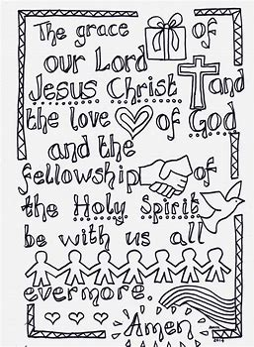

**18th October 2020 - Glynis and Neil**

**Hymn MP 496 O for a thousand tongues to sing**

O for a thousand tongues to sing

my great Redeemer's praise,

the glories of my God and King,

the triumphs of His grace!

Jesus! the name that charms our fears,

that bids our sorrows cease;

'tis music in the sinner's ears,

'tis life, and health, and peace.

He breaks the power of cancelled sin,

He sets the prisoner free;

His blood can make the foulest clean;

His blood availed for me.

He speaks, and, listening to His voice,

new life the dead receive,

the mournful, broken hearts rejoice,

the humble poor believe.

Hear Him, ye deaf; His praise, ye dumb,

your loosened tongues employ:

ye blind, behold your Saviour come;

and leap, ye lame, for joy.

My gracious Master, and my God,

assist me to proclaim,

to spread through all the earth abroad,

the honours of Thy name.

Charles Wesley (1707- 88) altd. CCLI 150801

**Prayers of Adoration & Lord’s Prayer** (sung)

**Notices followed by Mission Prayer**

**Dedication of Offertory**

**Song: You Tube Video –**

I lift My Hands to the Coming King (7:24)

**1st Reading** - 2 Kings 6:8-17

**Hymn MP 506 How Great Thou Art**

O Lord my God! when I in awesome wonder

consider all the works Thy hand hath made.

I see the stars, I hear the mighty thunder,

Thy power throughout the universe displayed;

*Then sings my soul, my Saviour God, to Thee,*

*How great Thou art, how great Thou art!*

*Then sings my soul, my Saviour God, to Thee,*

*How great Thou art, how great Thou art!*

When through the woods and forest glades I wander

and hear the birds sing sweetly in the trees

when I look down from lofty mountain grandeur,

and hear the brook, and feel the gentle breeze;

*Then sings my soul*....

3. Covid restriction mean that we are limited in the number of people who can gather. Is there a way of turning that round, and seizing the opportunity to become cells of committed disciples, praying and working together in mission?

4. In the extended period of Covid-19 restrictions, how can the church continue (or resume?) the challenge to nurture discipleship and make new disciples? How do we make sure, if much of our activity is online, that we are also engaging in faith conversations with the wider communities in which we are set?

5. Climate change sits alongside the current Covid-19 situation as a major challenge to the way we live. How do we keep climate change on the agenda? How can the church ensure that we continue to address the questions of our environmental impact and sustainable living?

6. We are feeling the effects of the ‘digital divide’ – with some much more able than others to use the benefits of technology to keep in touch and engage with social activity, and of course the life of the church. What questions is this raising about how inclusive or exclusive the church is or can be?

**On 12th September I attended a zoom morning called Yorkshire Synod Café where the 70 representatives from around Synod there put forward the following questions for discussion at Synod last Saturday**

**(10th October)**

**113 representatives attended Synod on the 10th and we were put in break out rooms in the afternoon to discuss the following and report back – our feedback is being written up but I wanted to share these with you all –**

**if you have any comments please let me know and I will add them into the future conversations.**

1. What can the church do to support those whose mental health is suffering as a result of Covid-19? How in general can the church raise awareness of mental health issues, increase understanding of them, and respond to the need?

2. Individuals, communities and nations are going to need resilience to see us through the current crisis. Resilience is closely related to hope. What role could/should the church have in building resilience and expressing hope?

And when I think that God His Son not sparing,

sent him to die - I scarce can take it in,

that on the cross my burden gladly bearing,

He bled and died to take away my sin:

*Then sings my soul*....

When Christ shall come with shout of acclamation

and take me home - what joy shall fill my heart!

Then shall I bow in humble adoration,

and there proclaim, my God, how great Thou art!

*Then sings my soul*....

tr STUART K HINE (1899-1989) © 1953 Stuart K Hine/The Stuart Hine Trust/Kingsway Music CCLI 150801

**2nd Reading** - John 4:1-26

**Hymn MP 582 Rock of Ages**

Rock of ages, cleft for me,

let me hide myself in Thee;

let the water and the blood,

from Thy riven side which flowed,

be of sin the double cure,

cleanse me from its guilt and power.

Not the labour of my hands

can fulfil Thy law's demands;

could my zeal no respite know,

could my tears for ever flow,

all for sin could not atone;

Thou must save, and Thou alone.

Nothing in my hand I bring,

simply to Thy cross I cling;

naked, come to Thee for dress,

helpless, look to Thee for grace;

foul, I to the fountain fly;

wash me, Saviour, or I die.

While I draw this fleeting breath,

when mine eyes shall close in death,

when I soar through tracts unknown,

see Thee on Thy judgement throne;

Rock of ages, cleft for me,

let me hide myself in Thee.

Augustus Montague Toplady (1740-78) CCLI 150801

**Talk** – Glynis

**Introduction: Open my eyes so that I may see**

Elisha in Verse 17 was not talking about physical eyes but spiritual eyes. Our physical eyes are limited to what they can see but our spiritual eyes can see the deep and hidden things from God.

This is my prayer everyday - Lord open my eyes so that I can see mysteries hidden from my physical eyes.

What Elisha's servant saw was beyond words - he looked and saw the hill full of horses and chariots of fire all around Elisha. Do you think he was scared of the Arameans anymore? I don't think so, but he remembered what Elisha told him in Verse 16 "Those who are with us are more than those who are

In pity angels beheld Him,

and came from the world of light,

to comfort Him in the sorrows

He bore for my soul that night.

*How marvellous . ..*

He took my sins and my sorrows,

He made them His very own;

He bore the burden to Calvary,

and suffered, and died alone.

*How marvellous . ..*

When with the ransomed in glory

His face I at last shall see,

'twill be my joy through the ages

to sing of His love for me.

*How marvellous* . . .

Charles Hutchinson Gabriel (1858- 1932) CCLI 150801

**The Grace**

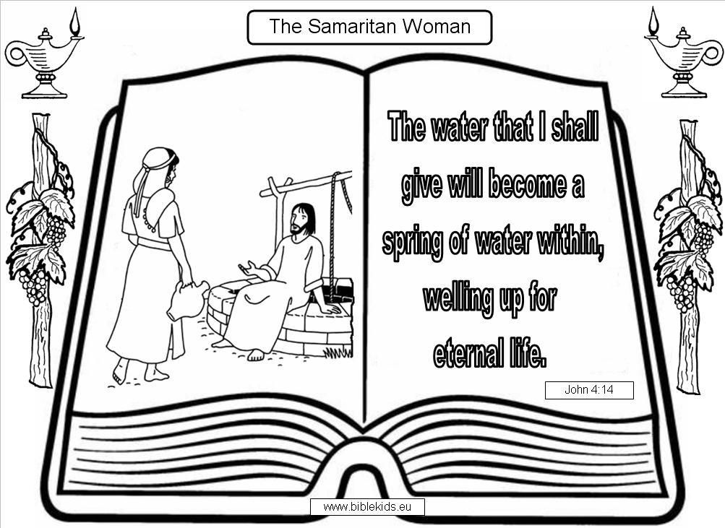

she became the 1st evangelist in Samaria. Nothing is impossible with God. Maybe this time of covid-19 is our unscheduled time with God. To sit by the well so as to get filled by streams of living water so that we can overflow to what God has in store for us. What a dew is to the flower, gentle words are to the soul.

**Prayers of Intercession**

**You Tube Video: BE KIND –**

Inspirational & Motivational Video (11:09)

***Shine* share their mornings devotions and work**

**Hymn MP 296 I stand amazed in the Presence**

I stand amazed in the presence

of Jesus the Nazarene,

and wonder how He could love me,

a sinner, condemned, unclean.

*How marvellous! how wonderful!*

*and my song shall ever be:*

*How marvellous! how wonderful!*

*is my Saviour's love for me!*

For me it was in the garden

He prayed - 'Not My will, but Thine';

He had no tears for His own griefs,

but sweat drops of blood for mine.

*How marvellous* .. .

with them." Child of God - I want to encourage you that those who are with you (God's armies) are greater than those in the world. If God can open your eyes - you will see what I am talking about.

In John 4 we see that Jesus had to go through Samaria because there was a woman there who needed her eyes opening to see who she was not in order to move forward and leave her old self. This was Gods perfect moment to open her eyes and set her free from manizing.

**Psalm 119 v 18 says: Open my eyes so that I may see wonderful things in your law.** 2 Kings v 8-18 we find a beautiful story about Elisha trapping the Arameans who were at war with the Israelites. Each and every time they plot to set a camp against Israel, Elisha knew about because he was a prophet of the Most High God. The King of Aram thought there was a traitor amongst them because Israel always find out about their plan and someone revealed that Elisha was the informer.

In verse 13 we find out the king ordered that he should be discovered and obviously he was gonna be killed, but Elisha knew who he was, a servant of the Most High God, the revealer of mysteries. The bible says the king of Aram sent horses chariots and a strong force to capture him

Upon seeing them Elisha's servant was petrified but the prophet of God said: Do not be afraid for those who are with us are more than those are with them.

And Elisha prayed; O Lord open his eyes so that he may see:

And the Lord open his eyes and wow, saw what Elisha saw , the hill full of horses and chariots of fire all around Elisha.

**Open my eyes to see the seventh man in my life.**

In the book of John 4 v 4 the bible says "Jesus had to go through Samaria. I don't know how long the journey was but the bible says Jesus was tired and thirsty because of the journey therefore He sat down by the well and it was about noon. When the Samaritan woman came to draw water, Jesus said to her "will you give me a drink". The woman responded by saying to Him "but You are a Jew and I am a Samaritan woman. How can You ask me for a drink?" [for Jews do not associate with Samaritans]

For this woman - who came to fetch water when there was no one around because of the fear of being insulted - this was God's unscheduled time for her delivery. This was her breakthrough moment. Although Jesus was tired and thirsty for physical water but this woman was more tired and thirsty for living waters. God scheduled her time to be set free from embarrassment and insults. Jesus had to go through Samaria especially for this child of God who has been an outcast for years. She had 5 men in the past and the 6th man was not even hers. She needed a 7th man, for this was her time of perfection and completeness.

In Philippians 1 v 6 the bible declares that “He who began a good work in you, will carry it on to completion until the day of Christ Jesus”. God is in a recycling business, turning trash into treasure. I don't know about you, Neil and myself often experience some challenges [Most of the times it's coming from my children and poor Neil has to suffer the consequences] that is why I personally get tired and I discovered that as I sit down by the well to invite the Holy Spirit to be my Comforter, my Teacher and my Paraclete, I get rejuvenated, revived and refreshed. I thank God for Neil because each day he encourages and edifies me in my walk with God. Sometimes he will just say one word and when I sit down and meditate upon what he said, I could feel the empowerment of the Holy Spirit, reviving my soul. Hallellujah.

We cannot minister to others if we are tired and thirsty. We need the filling of the Holy Spirit to renew our old wineskin into new. We need a 7th Man [Jesus] to be our Lord and our shepherd. He is the only one who can give us streams of living water as He said to this Samaritan woman “If you knew the gift of God and who is that asks you for a drink, you would have asked Him and He would have given you living waters”. This woman needed a 7th man in her life to set her free from her bondage, to quench her thirst for men and a breakthrough to be what God called her to be. She wouldn't speak to anybody but when she had an encounter with Jesus,