 **Westfield URC**

**Weekly Notice Sheet**

**for 18th October 2020**

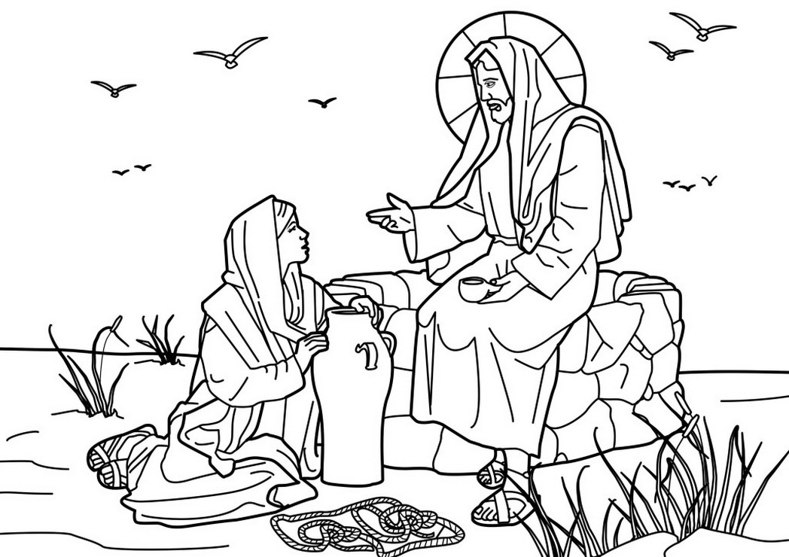

**If you have anything you want to share with the fellowship week by week please email it to Kath by Tuesday evening or ring and we will try to include it on the next weekly sheet.**

**Items to Marjorie for December / January newsletter by 15th November please.**

**Secretary: Kath Lonsdale: 01274 315203; 07759525936**

[**kathlonsdale@talktalk.net**](mailto:kathlonsdale@talktalk.net)

**Treasurer: Marjorie Hunt: 01274 677115**

**Westfield elders invite you to use the readings, prayers and reflections at 10.30am Sunday morning, if you are unable to be in church, to help us worship together in Spirit. This week Glynis and Neil lead our service .**

**Advanced notices**

Tuesday 20th 7pm Bible Study 1&2 Corinthians part 1

Wednesday 21st 2pm Bible Study 1&2 Corinthians part 1

Sunday 25th October 9.30am Prayers

10.30am morning service John Wilson

|  |  |  |  |  |
| --- | --- | --- | --- | --- |
|  |  |  |  |  |

**Pause for thought :**

There is much talk of what the world post Corvid-19 might look like and encouragement to churches to think about how the experience will shape their future ministry and mission. Of one thing we can be sure, as the Thessalonians found, that future must be built on having God at the centre, enabling a faithful, hopeful and loving people to be witnesses in a changing world.  
**Prayer**  Eternal God,

We hear your call to be faithful, hopeful and loving citizens of your kingdom. May our joy in your service inspire us to witness to you, our living and true God. Amen

**I**

**Basil’s memories (13)**

We’re off again. Guernsey is very familiar to me. My youngest daughter went there on holiday in1993 and was married there in 1995. Her silver wedding was 23rd September 2020. As a result my wife and I were frequent visitors. I’ve been there 30 times, even 3 times a year sometimes.

Guernsey is the second biggest of the channel islands after Jersey, but is responsible for the smaller islands-Herm, Sark, Alderney, Brecqhou and Uhou.

Usually I’ve travelled from Manchester Airport but you can go by road and ferry from Poole. Guernsey is unique now in having it’s

own currency including the £1 note, but with UK coins and notes readily available. There is no VAT although most things are imported and therefore more expensive.

Like almost everywhere in the world Guernsey suffers from traffic and traffic jams at peak times. Most of the roads are quite narrow and closed to big vehicles except buses. To allow for road works or big vehicles like removal vans, the road has to be closed and closures are listed in the island newspaper.

I’ve walked many a mile all over the island and driven the 56 miles of the coastal road. Nowhere is more than three miles away. There is much to see all over the lovely island but you can’t miss all the concrete defence works built by the Nazis using slave labour. All shapes and sizes, plus all the tunnels built to house the thousands of German soldiers based there from 1940 to 1945. My daughter’s parents in law stayed there throughout the occupation and had many stories to tell. The island is lovely and just a few degrees warmer that the UK most of the time. There are any number of glorious beaches, particularly on the west coast – Cobo Bay and Vazon Bay for example, St Peter Port is the capital and biggest town. I love to watch the port movements. There’s always something going on…it’s a busy place.

***B.P.H***

Westfield's%20Prayer%20for%20growth.pdf

**Noticeboard witness:**

**If you have a bible text for sharing an Advent, Christmas or New Year message to those walking or driving past our notice board please let me have it/them by the end of October so I can get some more posters printed by mid November.**

***Blessings Kath***

**Westfield URC, Westfield Lane, Wyke, BD12 9DB** [**www.WestfieldURC.org**](http://www.WestfieldURC.org)

**please look at the calendar for future information or ring any elder Marjorie, Pauline, Neil, Glynis or Kath.**