 **Westfield URC**

**Weekly Notice Sheet**

**For 8th November 2020**

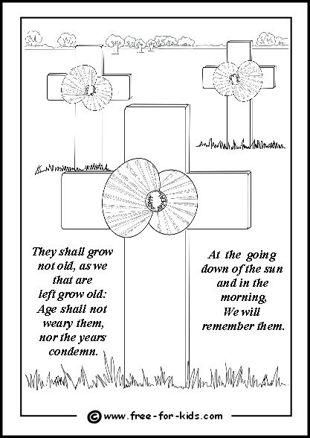

**If you have anything you want to share with the fellowship week by week please email it to Kath by Tuesday evening or ring and we will try to include it on the next weekly sheet.**

**Items to Marjorie for December / January newsletter by 15th November please.**

**Secretary: Kath Lonsdale: 01274 315203; 07759525936**

[**kathlonsdale@talktalk.net**](mailto:kathlonsdale@talktalk.net)

**Treasurer: Marjorie Hunt: 01274 677115**

**Westfield elders invite you to use the readings, prayers and reflections at 10.30am Sunday morning to help us worship together in Spirit. This week Andrew shares with us, on the separate sheet, our Remembrance service .**

**Up date :**

After the news that we are moving into Tier 3 on Monday 2nd November the elders have made the decision, with some sadness, to have a break from all meetings in the school rooms. Although we are sure we have a safe environment with all the extra cleaning, track and trace, social distancing and one way system we feel that if everyone in our area supports a lockdown now we can hopefully safely return for Advent to celebrate together the birth of our Saviour.

**We will again deliver weekly sheets** to everyone for the next 3 Sundays and keep in touch by phone. **Please ring** any elder if you need anything, want someone to pray with or just want a chat.

**We plan to reopen** **for Advent** :

Sunday 29th November 9.30am Prayers

10.30am Advent 1 – Kath

Tuesday 1st December 7pm Bible study

1&2 Corinthians part 2

Wednesday 2nd December 2pm Bible study

1&2 Corinthians part 2

**Rotas :** Shine Glynis & Annette

Welcome Glynis

Duty Elder Marjorie

|  |  |  |  |  |
| --- | --- | --- | --- | --- |
|  |  |  |  |  |

**I**

Basil’s memories (16)

Driving south showed just how quiet is New Zealand and yet they have such first quality roads.

Travelling for just two hours we passed only two vehicles. But New Zealand is rich in the culture of fruit and nuts. It has been a good year and a large variety was on sale by the road side. We stopped somewhere in the middle of the Canterbury Plain alongside the “ Church of the Good Shepherd ”- open to all denominations and well filled every two or three weeks. It was officially opened by the former Duke of Gloucester in 1935.

On the way south of the south island towards Queenstown we passed and called at quaint little townships with “story book names” like Twizel and Omarama. After booking in at the hotel in Queenstown we travelled to Fiordland. Lake Pukaki leads the way to Homer. This lake has a unique feature in it’s character in that when a storm rages from the adjacent Alps a chunk of material may break off, but instead of sinking to the bottom It floats! This is a natural pumice stone.

The only way to the Milford Sound is via the Homer tunnel cut through the mountain. The wonder and majesty of the fiord is revealed as you exit the tunnel. A vast area like a sheet of glass reflecting enormous peaks such as “Mitre Peak”

Alongside cascading waterfalls splashing down thousands of feet to the surface. And there, waiting for us was our cruise boat ready to take us on a right royal sail and buffet lunch for two hours throughout the glacial waters. The fiord has a secret out of sight line to the sea – a near right angled bend which explains why the surface is almost constantly calm. A wonderful experience. On the map all this activity is near the bottom left of the South Island. You can’t miss seeing the local residents, the Kea birds. Rather drab looking parrot like birds who prefer not to fly ! They strut around like land owners and are almost tame, but they are deadly in destruction. You are warned to make sure doors and windows of cars and coaches are closed. Otherwise, they jump in and wreck the upholstery within a few minutes. Back to Queenstown for the night and then into the mountains and our next exciting calling spots with almost familiar names.We’ve left the highest peak- Mount Cook for the adventurers and explorers. Our route follows the line of the Southern Alps all the way up to the west of the islands.

So there is more to come *B.P.H*

Westfield's%20Prayer%20for%20growth.pdf

**Noticeboard witness:**

**Thankyou for the quotes and texts – some of these will be on posters in the weeks to come…**

**For those not walking past church**

**This week’s poster is for Remembrance**

**We Remember and Pray for Peace**

**Jesus said “ Blessed are the peacemakers ”**

**Westfield URC, Westfield Lane, Wyke, BD12 9DB** [**www.westfieldurc.org**](http://www.westfieldurc.org)**.uk**

**please look at the calendar for future information or ring any elder Marjorie, Pauline, Neil, Glynis or Kath.**