 **Westfield URC**

**Weekly Notice Sheet**

**For 22nd November 2020**

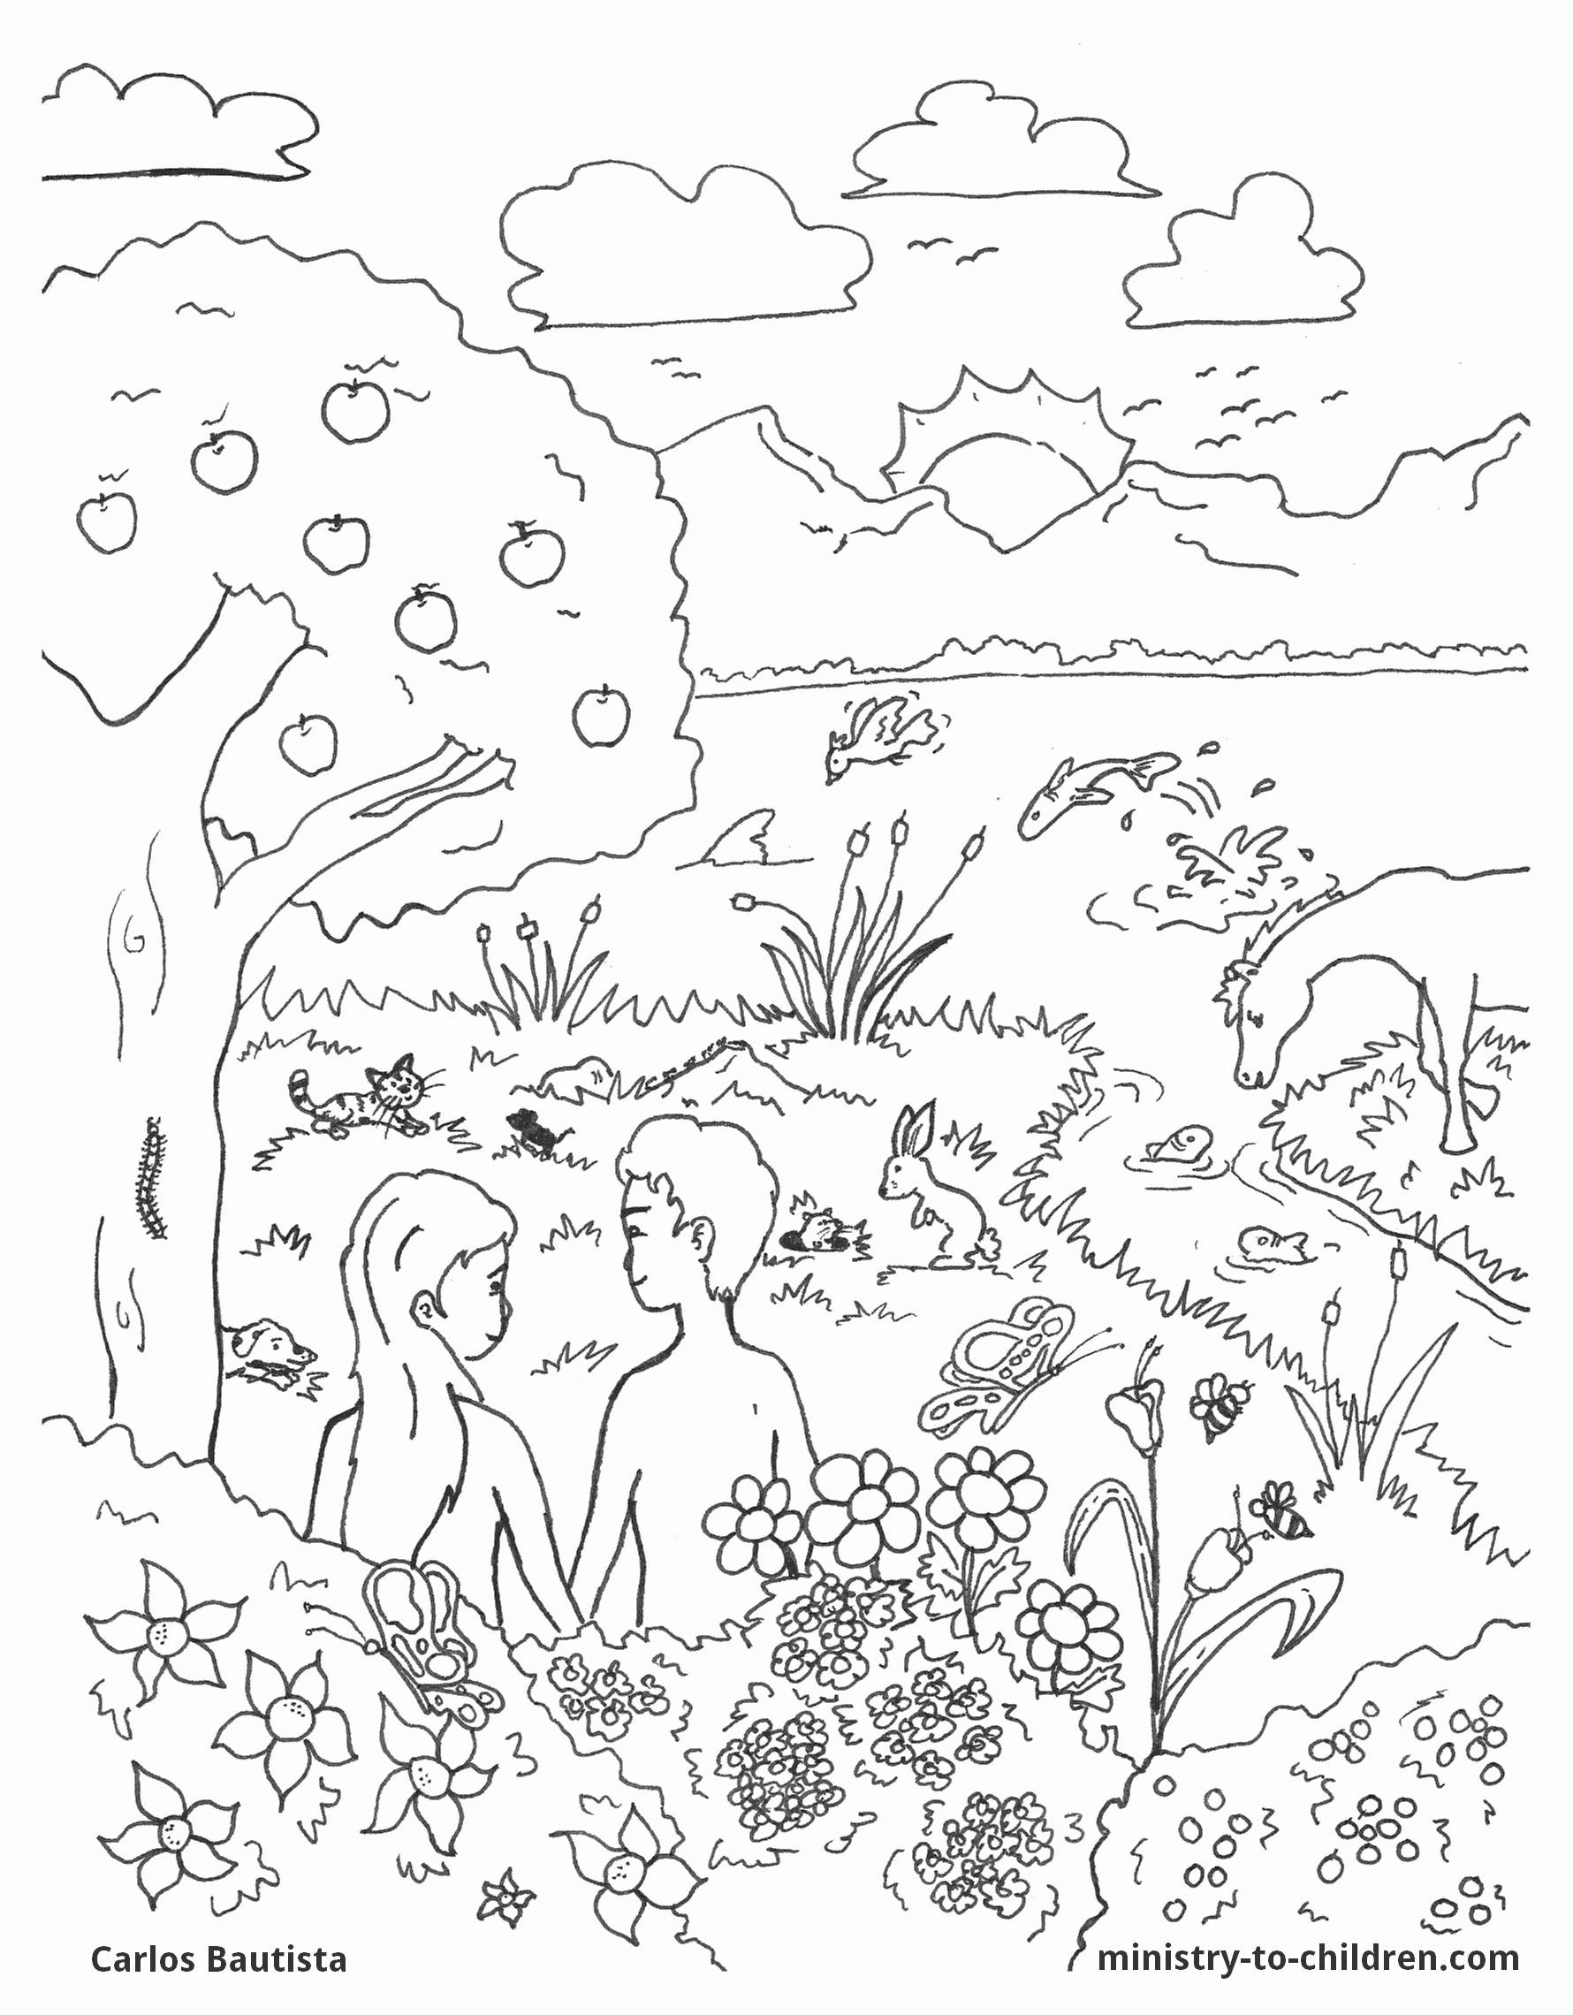

**If you have anything you want to share with the fellowship week by week please email it to Kath by Tuesday evening or ring and we will try to include it on the next weekly sheet.**

**Secretary: Kath Lonsdale: 01274 315203; 07759525936**

[**kathlonsdale@talktalk.net**](mailto:kathlonsdale@talktalk.net)

**Treasurer: Marjorie Hunt: 01274 677115**

**Westfield elders invite you to use the readings, prayers and reflections at 10.30am Sunday morning to help us worship together in Spirit. This week Paul Hallam shares with us, on the separate sheet.**

Foodbank shortages:

Small packets of soap powder Washing up liquid

Toilet Rolls Deodorant – male & female

Anti bacterial handwash

Tinned potatoes Sponge puddings

Please let Kath and Andrew know if you want any contributions picking up whilst church is closed.

Please ring any elder if you need anything, want to pray or just have a chat whilst we are closed through November.

Sunday 6th December 9.30am Prayers

10.30am 2nd in Advent

including communion Andrew

6.30pm Evening service Neil

Sunday 13th December 9.30am Prayers

10.30am Nativity Kath & Andrew

|  |  |  |  |  |
| --- | --- | --- | --- | --- |
|  |  |  |  |  |

**I**

**Basil’s memories (17) update**:

Unfortunately the gremlins got into the production system and performed a Strictly dance on the keyboard. As a result, if you are interested, delete the bottom 9 lines as published last week and replace them with the following:

…of Wellington. Government House is known as “The Beehive .” It’s construction really does justify the title and my photo will confirm that. The huge sports arena is known as “The Cake Tin” again justified by appearance and design. It is a busy city with two cathedrals. A very old wooden example used only on special occasions or weddings, and a relatively modern building “uptown”. We were travelling through a very different landscape from South Island. Rich farmland and an introduction to Maori influences. Names such as Mount Ruhapehu, Ngauruhue. We are faced with a Maori ‘hangi’.

What could that be? Read memories 18 to find out. Aha. *B.P.H*

**Basil’s memories (18)**

We are now approaching the Maori area where the first locals have a large measure of autonomy - native language, native buildings and decorations, yes even to rubbing noses! Being a country of sheep it is right and proper for some of them to appear in the Agrodrome Hall, - a stepped platform with placards naming 16 breeds of sheep. As the music plays one sheep at a time is released from the fold and climbs up the step to stand behind the appropriate placard. The process continues until all 16 places are occupied by the total variety of breeds. They are followed by a sheep dog climbing on the backs of all the sheep and make a ‘bow’ at the top. Then the shearing champion comes on to shear a sheep in less than 2 minutes.

Rotarua is our base and five star hotel, but beyond is the Thermal Reserve which includes more than 20 living mud pools, shooting frequent columns of sulphurous mud. Can be very frightening to some but astounding to behold. There is no known ending to these activities.

Into the heart of Maoriland, to their own school where young people demonstrate their ancient skills such as carving. It wasn’t long before the stage was filled with their group in Maori costume and making their mellifluous music to their dancing. They were good and well trained.

From there to the Waitomo caves, here we took a boat ride along the underground rivers through magnificent caves lit by millions of glow worms lining the roofs of the caves. An imaginary fairyland that was actually real.

On our last evening in Rotarua we were collected by our Maori guides and taken to their centre. After a traditional Maori challenge and welcome we were entertained by a lavish show of music and dance, including the haka, followed by – you’ve waited for it – the hangi. A Maori dinner cooked in an earthen pit. No electric, no gas; just earth but all cooked to perfection - wild pork, lamb, seafood and vegetables, all steam cooked outside and delicious.

Finally, back to Auckland on our last day. Following a tour of the city we arrived at the Sky tower, standing about 1,000ft into the sky. The tallest building in the southern hemisphere. Some of us went up in the lift, not quite to the top. At 800ft plus it was enough and stepping out of the lift on to a glass floor. Quite a thrill especially when the people passed outside on their way down to the bottom of the Bungy Jump in their harness.

I left the party in Auckland and flew to Brisbane to meet my hostess for the next week or so on the Gold Coast. So that’s the end, or at a pause in a wonderful experience. Where next? Who knows?

*B.P.H*

Westfield's%20Prayer%20for%20growth.pdf

Noticeboard witness:

For those not walking past church

this week’s poster is

“It is better

to take refuge in the Lord,

than to trust in man.”

Psalm 118 v 8

**Westfield URC, Westfield Lane, Wyke, BD12 9DB** [**www.westfieldurc.org**](http://www.westfieldurc.org)**.uk**

**please look at the calendar for future information or ring any elder Marjorie, Pauline, Neil, Glynis or Kath.**