 **Westfield URC**

**Weekly Notice Sheet**

**For 29th November 2020**

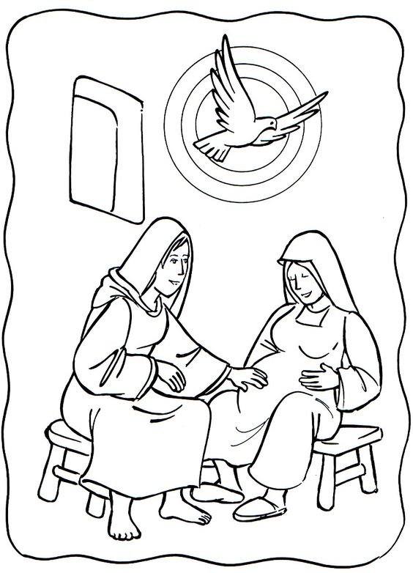

**If you have anything you want to share with the fellowship week by week please email it to Kath by Tuesday evening or ring and we will try to include it on the next weekly sheet.**

**Secretary: Kath Lonsdale: 01274 315203; 07759525936**

[**kathlonsdale@talktalk.net**](mailto:kathlonsdale@talktalk.net)

**Treasurer: Marjorie Hunt: 01274 677115**

**Westfield elders invite you to use the readings, prayers and reflections at 10.30am Sunday morning to help us worship together in Spirit. This week Kath shares with us, on the separate sheet.**

**Foodbank shortages:**

Small packets of soap powder

Washing up liquid

Toilet Rolls

Deodorant – male & female

Anti bacterial handwash

Tinned potatoes

Sponge puddings

Please let Kath and Andrew know if you want any contributions picking up whilst church is closed.

Please ring any elder if you need anything, want to pray or just have a chat whilst we are closed through November.

Beginning of next week Andrew and Kath will get Christmas decorations out and leave them spaced around the Hall and Ellis Room ready for putting up safely

If you can help decorate please let Kath know - we aim to decorate later in the week. (after 2nd Dec Covid advice dependant )

Sunday 6th December 9.30am Prayers

10.30am 2nd in Advent

including communion Andrew

6.30pm Evening service Neil

Sunday 13th December 9.30am Prayers

10.30am Nativity Kath & Andrew

|  |  |  |  |  |
| --- | --- | --- | --- | --- |
|  |  |  |  |  |

**I**

**Basil’s memories (19)**

Of all the memories, there is one which is perhaps the shortest but very unforgettable. On the 9th September 2001 my brother and I set off for San Diego in California. We flew from Manchester to Gatwick to board British Airlines newest aircraft – a Boeing 777 going nonstop to San Diego in about 11 hours. Then back to reading or sleeping or whatever you would do on a long haul flight.

It was after about five hours when the speaker system came into life - “This is the Captain speaking, I have been ordered to turn around and return to UK. There has been an incident in New York and America has closed its borders. So too has Canada. That means that no aircraft can land or take off in those countries ”We were just less than half way so we had enough fuel to return to UK, otherwise we would have to land in either Greenland or Iceland. We knew no more and assumed there had been an air crash. The pilot could say no more except that we were to land at Glasgow (Prestwick). That is the emergency airport for aircraft crossing the Atlantic and experiencing difficulties.

And so we made the return flight with no more news except the pilot told us he had been cleared to land at Gatwick.

When we did land we were stuck at the end of the runway. The whole airport was heaving but buses did come to take us into the melee. Packed like sardines, with BA staff walking around carrying trays of soft drinks and sandwiches. We managed to get to the British Midland desk and book our return flight to Manchester the next day without any problems.

In the meantime my brother’s daughter Wendy who lived quite near Crawley, had heard the news and knew we were travelling. We collected our baggage at the carousel and fought our way to the exit barrier, and, wonder of wonders, there was Wendy looking out for us. I don’t know how she found a parking space but we were soon at her house. Her husband Tony and son Jamie had arrived home.

It was, of course, 9/11 when the terrorists struck the twin towers in New York. We were very fortunate, having a bed for the night while thousands were stuck at Gatwick.

We flew back to Manchester, next day, very relieved, since the terrorists chose British Airways aircraft to perform their deadly deeds.

The real bonus for us was that within 10 days, we received repayment for the airfare including the return trip from Manchester less £1!!!

*B.P.H*

Westfield's%20Prayer%20for%20growth.pdf

Noticeboard witness:

For those not walking past church

this week’s poster is

“It is better

to take refuge in the Lord,

than to trust in man.”

Psalm 118 v 8

**Westfield URC, Westfield Lane, Wyke, BD12 9DB** [**www.westfieldurc.org**](http://www.westfieldurc.org)**.uk**

**please look at the calendar for future information or ring any elder Marjorie, Pauline, Neil, Glynis or Kath.**