 **Westfield URC**

**Weekly Notice Sheet**

**For 13th December 2020**

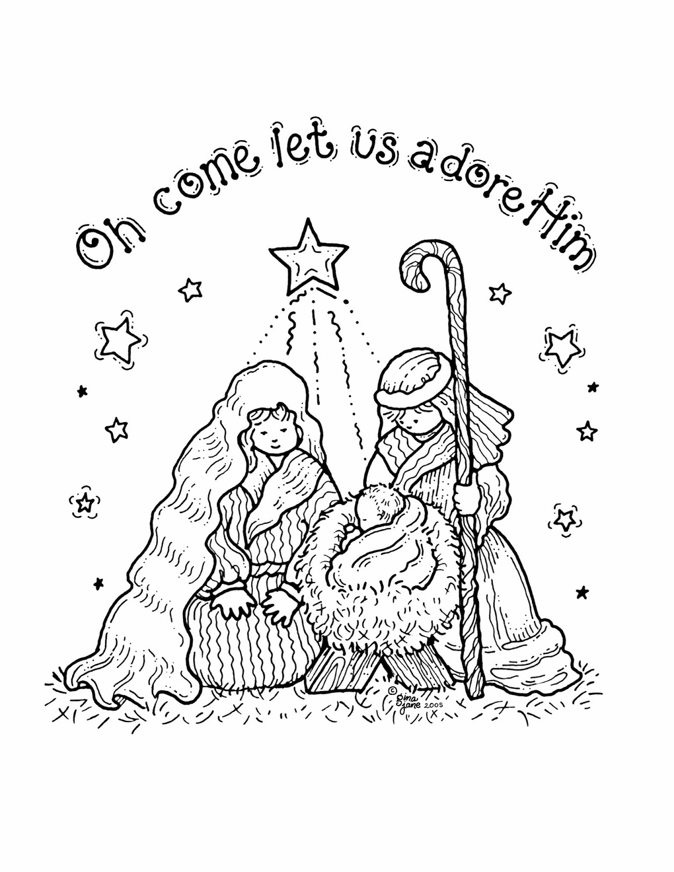

**If you have anything you want to share with the fellowship week by week please email it to Kath by Tuesday evening or ring and we will try to include it on the next weekly sheet.**

**Secretary: Kath Lonsdale: 01274 315203; 07759525936**

[**kathlonsdale@talktalk.net**](mailto:kathlonsdale@talktalk.net)

**Treasurer: Marjorie Hunt: 01274 677115**

**Westfield elders invite you to use the readings, prayers and reflections at 10.30am Sunday morning to help us worship together in Spirit. This week Andrew & Kath share with us for our nativity Sunday.**

Monday 14th December 6pm Elders by email /phone

Tuesday 15th December 7pm Bible study

(1 & 2 Corinthians pt 2.)

Wednesday 16th December 2pm Bible study (as Tuesday)

Sunday 20th December 9.30am Prayers

10.30am Morning service Neil & Glynis

6 pm Carols by candlelight Kath

**Please return your carol choices by 13th December and If you are willing to read please let Kath know.**

Christmas Day 25th December **10.30am**

Andrew including communion.

Sunday 27th December 9.30am Prayers

10.30am Morning service Robin

|  |  |  |  |  |
| --- | --- | --- | --- | --- |
|  |  |  |  |  |

**I**

Happy Birthday Nora

From all your Westfield friends



**To those who speed on the motorway – a few hymns**

(Thankyou for this Robin)

45mph - God will take care of you; 65mph - Nearer my God to Thee;

85mph - Lord I’m coming home; 100mph - Take my hand precious Lord;

120 mph - Take my hand precious Lord; 150mph - The Master has called;

**Basil’s memories (21)**

On 7th June 2006 my brother and I went to China for three weeks with a bit of apprehension, but the doubts came to nothing and it turned out to be an excellent trip. It was a long flight by Virgin airways Jumbo – 121/2 hours. There were about 30 in our party, and our first destination was Hong Kong. It had only recently gone back to Chinese rule after being a British colony for about 100 years. The place was very active, exciting and non-stop.. we were introduced to our 5 star hotel promptly, there were still lots of Union Jacks around and almost everyone spoke English. The largest part of H.K. is on the mainland and is called Kowloon. My brother and I found a little restaurant and enjoyed a fish meal. It was a good choice and centred around a “braised mandarin” fish. First class! Much of the area of the islands of H.K. is occupied by skyscrapers. Big business thrives.

In between the waters are filled with lots of houseboats and sampan ferries. The boats are rather dirty and very scruffy and the powers are trying to get rid of them, mainly for hygiene reasons.

We were introduced to the jewellery quarter, a very rich and expensive corner, but because it was Sunday I came across a group of mainly young folk, singing familiar gospel songs and choruses in a circle on the harbour front. I knew most of the items and could join in. They invited me to join the circle. They were very enthusiastic in their witness.

It was a very active 2 days in H.K. before we took flight again to the very old former Chinese capital – Xian and more mysteries. A 2/12 hour flight with a Mongolian guide who spoke English like a native, !, can you imagine saying “ Ee By Gum” with a Mongolian accent ? He stayed with us throughout and did a thoroughly good job. You’ll like the next section - Number 22.

*B.P.H*

Adam Woodhouse has received and accepted a call to the East Lancashire Mission Partnership next year. The group of churches he will share with 2 other ministers are :Accrington & Revidge Fold, Trinity Blackburn & Westbury gardens, Blackburn Ragged School & Blackburn Woodlands, Burnley, Nelson, Clitheroe, Bolton Road Darwen & Central Darwen, Tockholes & Trinity Lower Darwen & Great Harwood Trinity (United with Methodist). Please continue to pray for Adam as he carries on with his final placement in Ipswich and prepares to move July/August 2021.

Westfield's%20Prayer%20for%20growth.pdf

Noticeboard witness:

For those not walking past church

this week’s poster is

God loves you.

He sent His Son for you and me

at Christmas.

Oh come let us adore Him.

**Westfield URC, Westfield Lane, Wyke, BD12 9DB** [**www.westfieldurc.org**](http://www.westfieldurc.org)**.uk**

**please look at the calendar for future information or ring any elder Marjorie, Pauline, Neil, Glynis or Kath.**