**O come, all you faithful,**

O come, all you faithful,

joyful and triumphant,

O come now, O come now to Bethlehem;

come and behold him born the King of angels:

*O come, let us adore Him, (x3)*

*Christ the Lord.*

True God of true God,

Light of light eternal,

He, who abhors not the virgin's womb;

Son of the Father, begotten not created:

*O come, let us adore Him.....*

Sing like the angels,

sing in exultation,

sing with the citizens of heaven above,

'Glory to God, glory in the highest':

*O come, let us adore Him.....*

Yes, Lord, we greet You,

born that happy morning,

Jesus, to You be glory given!

Word of the Father, now in flesh appearing:

*O come, let us adore Him.....*

Latin, 18th cent., tr Frederick Oakley (1802-80) © 1986 Horrobin Leavers CCLI 150801

**Blessing**

**Carols by Candle-light** **Kath**

**6pm** **20th December 2020**

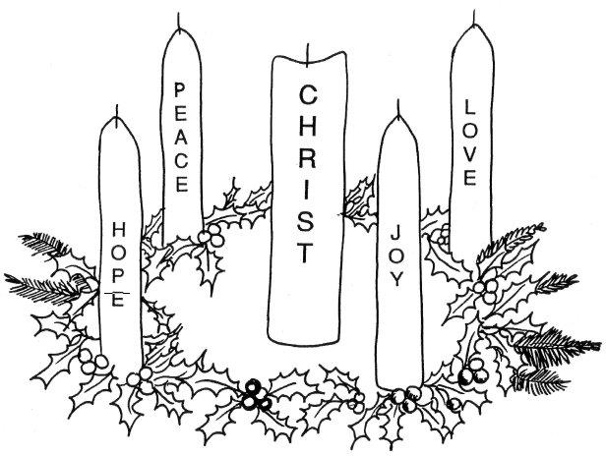

**Call to worship** Isaiah 7:14

**O little town of Bethlehem,**

O little town of Bethlehem,

how still we see you lie!

Above your deep and dreamless sleep

the silent stars go by:

yet in your dark streets shining

the everlasting light;

the hopes and fears of all the years

are met in you tonight.

For Christ is born of Mary;

and, gathered all above,

while mortals sleep, the angels keep

their watch of wondering love.

O morning stars, together

proclaim the holy birth,

and praises sing to God the King,

and peace to men on earth.

How silently, how silently,

the wondrous gift is given!

So God imparts to human hearts

the blessings of His heaven.

No ear may hear His coming;

but in this world of sin,

where meek souls will receive Him, still

the dear Christ enters in.

at the dawning of Immanuel!

King of heaven now the friend of sinners,

humble servant in the Father's hands,

filled with power and the Holy Spirit,

filled with mercy for the broken man.

Yes, He walked my road and He felt my pain,

joys and sorrows that I know so well;

yet his righteous steps give me hope again -

I will follow my Immanuel!

Through the kisses of a friend's betrayal

He was lifted on a cruel cross;

He was punished for a world's transgressions,

He was suffering to save the lost.

He fights for breath, He fights for me,

loosing sinners from the chains of hell,

and with a shout our souls are free -

death defeated by Immanuel!

Now He's standing in the place of honour,

crowned with glory on the highest throne,

interceding for his own beloved

till His Father calls to bring them home.

Then the skies will part as the trumpet sounds

hope of heaven or the fear of hell;

but the Bride will run to her Lover's arms,

giving glory to Immanuel!

Stuart Townend © 1999 Thankyou Music CCLI 150801

**Prayers of Intercession Marjorie**

*Hark! Now hear the angels sing:*…

Now Joseph and his wife Mary  
Came to Bethlehem that night.  
They found no place to bear her Child,  
Not a single room was in sight.

*Hark! Now hear the angels sing:….*

By and by they found a little nook  
In a stable all forlorn.  
And in a manger cold and dark  
Mary’s little Boy/Child was born

*Hark! Now hear the angels sing:*…

Trumpets sound and angels sing,  
Listen to what they say!  
That man will live forevermore  
Because of Christmas Day!

*Hark! Now hear the angels sing:*…

**5th Lesson** John 1:1-14 Carol

**From the squalor of a borrowed stable,**

From the squalor of a borrowed stable,

by the Spirit and a virgin's faith,

to the anguish and the shame of scandal

came the Saviour of the human race.

But the skies were filled with the praise of heaven,

shepherds listen as the angels tell

of the gift of God come down to man

Holy Child of Bethlehem,

descend to us, we pray;

cast out our sin, and enter in;

be born in us today.

We hear the Christmas angels

the great glad tidings tell:

O come to us, abide with us,

our Lord Immanuel.

PHILLIPS BROOKS (1835-93) CCLI 150801

**Christmas Prayer and Lord’s Prayer**

**1st Lesson** Luke 1:26-36 Marjorie

**See Him lying on a bed of straw:**

See Him lying on a bed of straw:

a draughty stable with an open door;

Mary cradling the babe she bore -

the Prince of glory is His name.

*O now carry me to Bethlehem*

*to see the Lord appear to men* -

*just as poor as was the stable then,*

*the Prince of glory when He came.*

Star of silver, sweep across the skies,

show where Jesus in the manger lies;

shepherds, swiftly from your stupor rise

to see the Saviour of the world!

*O now carry ...*

Angels, sing the song that you began,

bring God's glory to the heart of man;

sing that Bethl'em's little baby can

be salvation to the soul.

*O now carry . . .*

Mine are riches, from Your poverty,

from Your innocence, eternity;

mine forgiveness by Your death for me,

child of sorrow for my joy.

*O now carry . . .*

Michael Perry (1942-96) © Mrs B Perry/Jubilate Hymns CCLI 150801

**2nd Lesson** Luke 2:1-7 Annette

**Silent night, holy night:**

Silent night, holy night:

sleeps the world; hid from sight,

Mary and Joseph in stable bare

watched o'er the child belovèd and fair,

sleeping in heavenly rest,

sleeping in heavenly rest.

Silent night, holy night:

shepherds first saw the light,

heard resounding clear and long,

far and near the angel-song,

'Christ the Redeemer is here,

Christ the Redeemer is here'.

Silent night, holy night:

Son of God, O how bright

love is smiling from Your face

Strike for us now the hour of grace,

Saviour, since You are born,

Saviour, since You are born.

JOSEPH MOHR (1792-l848) tr STOPFORD A BROOKE (l832- 1916) CCLI 150801

**3rd Lesson** Luke 2:8-20 Robin

**Poem The fourth wise man**

**O Holy Night - You Tube – Kings College Choir**

**4th Lesson** Matthew 2:1-12 Andrew

**Mary’s Boy Child**

Long time ago in Bethlehem  
So the Holy Bible say  
Mary’s Boy Child, Jesus Christ  
Was born on Christmas Day!

*Hark! Now hear the angels sing:  
“New King’s born today  
And man will live for evermore  
Because of Christmas Day!”*

While shepherds watched their flocks by night  
They saw a bright new shining star  
And heard a choir from heaven sing  
The music came from afar