 **Westfield URC**

**Weekly Notice Sheet**

**For 27th December 2020**

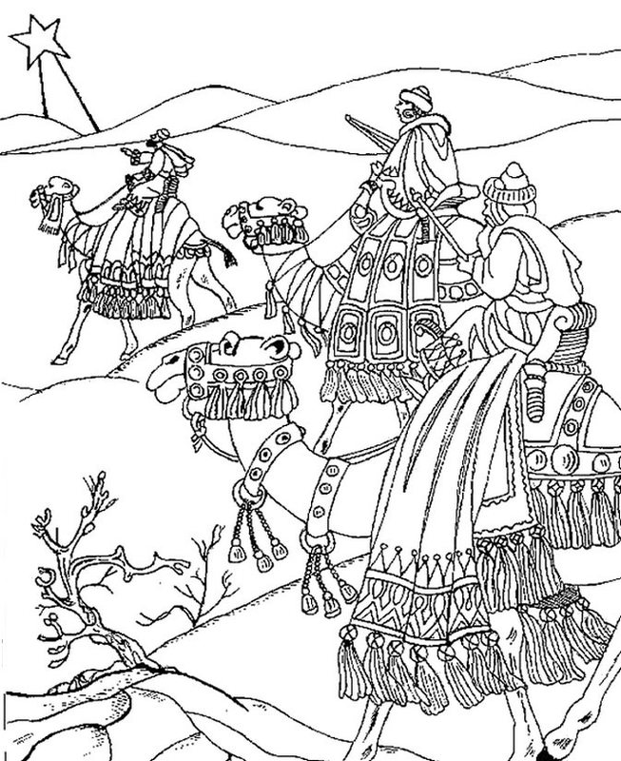

**If you have anything you want to share with the fellowship week by week please email it to Kath by Tuesday evening or ring and we will try to include it on the next weekly sheet.**

**Secretary: Kath Lonsdale: 01274 315203; 07759525936**

[**kathlonsdale@talktalk.net**](mailto:kathlonsdale@talktalk.net)

**Treasurer: Marjorie Hunt: 01274 677115**

**Westfield elders invite you to use the readings, prayers and reflections at 10.30am Sunday morning to help us worship together in Spirit. This week Robin shares with us.**

A very Peaceful, Healthy &

Happy New Year

to you and your family & friends.

|  |  |  |  |  |
| --- | --- | --- | --- | --- |
|  |  |  |  |  |

Sunday 3rd January 9.30am Prayers

10.30am morning service including receiving Annette (W) and Robin into membership, Rededication and Communion – Andrew

6.30pm evening service -Neil

Tuesday 5th January 7pm Bible Study Galatians

Wednesday 6th January 2pm Bible Study

Sunday 10th January 9.30am Prayers

10.30am Morning service – Graham Mallinson

**I**

**A very Happy Birthday Kath**

**From your Westfield friends**

 

**Please pray** for blessings for next Sunday when Robin and Annette (W) come into membership and together we recommit ourselves to God’s work and witness through Westfield in 2021.

**Basil’s memories (23)**

Beijing is mostly very modern. It looks old when you see Mao Tse Tung staring from over the gateway to the Forbidden City. Looking over the vast Tian an men Square it is easy to picture the TV lens showing the student facing the barrel of a tank gun a few years back. There are displays of all kinds each looked on by military characters who stand to attention motionless. There is a road passing one side of the square which extends in a straight line for 57 kilometres. Everywhere is thickly populated. The Forbidden City is no longer closed. After Mao Tse Tung’s death it was opened up. Miles of carpeted tunnels and some significant and extravagant exhibits. It was created to provide accommodation for the important families in case of revolution. Not far from the centre was the construction site for Olympics 2008 and their major stadium known as the Bird’s Nest. Already well advanced and well named.

Between the city centre and the building site were the simple cottages of the ordinary people called ‘Hutongs’. We travelled there in a rickshaw convoy. They are basic prefabricated homes built very close together. We were able to visit a few. They were very well maintained and occupied proudly. Not allowed to have animal pets but it was common for families to have crickets in cages! As we might have canaries. There was however much sadness. The hutongs were to be demolished to make way for accommodation for Olympic personnel, and afterwards for former hutongs dwellers.

Our hotel suites were brand new and of a very high standard, with a wide selection of western meals. Outstanding was the special sitting for their ‘Peking Duck dinner’. They kept the old name of their city in their menu. Each round table seated eight or ten people and each table had one duck and one chef. It was spectacular and very high quality. My one surprise was that when everyone had almost eaten their fill along came the rice! Well cooked and presented, but with limited take up. We were well satisfied by then. Beijing had many well kept parks and gardens all over the city and they were well used every morning with people exercising in the Chinese way – Tai Chi etc. and the likes. No classes or groups, but their own routines in their own time and way. I enjoyed watching them! You can’t visit Beijing without a trip to the Great Wall of China, not too far out, but simply amazing. A thousand miles long stretching out of sight both East and West. There are towers about 150 yards apart and the wall is about ten foot high with step access only from the inside. Mostly about eight foot wide at the top. A colossal building process taking a long time. There would never be a shortage of manpower.

Everything in China is big including the national emblem – the dragon – they are everywhere. Usually with a stone lion, and every lion has a stone in its mouth. There is much to see and do in China and I need one more piece to complete the saga… just one to go! *B.P.H*

Westfield's%20Prayer%20for%20growth.pdf

Noticeboard witness:

For those not walking past church

this week’s poster is

God loves you.

He sent His Son for you and me

at Christmas.

Oh come let us adore Him.

**Westfield URC, Westfield Lane, Wyke, BD12 9DB** [**www.westfieldurc.org**](http://www.westfieldurc.org)**.uk**

**please look at the calendar for future information or ring any elder Marjorie, Pauline, Neil, Glynis or Kath.**