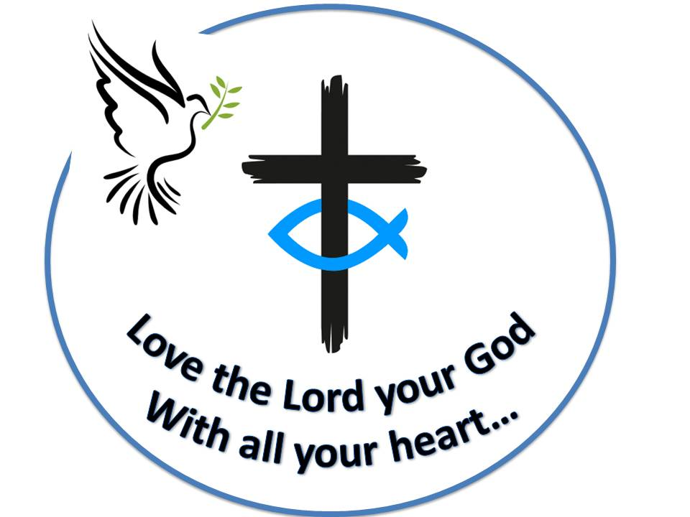 **Westfield URC**

**Weekly Notice Sheet**

**For 17th January 2021**

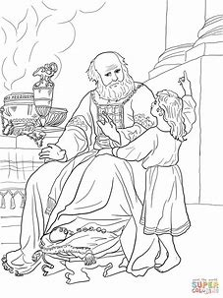

**“Speak Lord**

**Your servant**

**Is listening”**

**If you have anything you want to share with the fellowship week by week please email it to Kath by Tuesday evening or ring and we will try to include it on the next weekly sheet.**

**Secretary: Kath Lonsdale: 01274 315203; 07759525936**

[**kathlonsdale@talktalk.net**](mailto:kathlonsdale@talktalk.net)

**Treasurer: Marjorie Hunt: 01274 677115**

**Westfield elders invite you to use the readings, prayers and reflections at 10.30am Sunday morning to help us worship together in Spirit. This week Kath shares with us.**

February/March newsletter items due to Marjorie by today please

We aim to return to church on Sunday 7th February depending on the lockdown situation. Meanwhile Kath, Andrew or Carol will deliver your weekly sheets as in previous lockdowns and deliver activities to Imogen and Leo as before.

**If you need someone to pray with, a chat or need any help Please ring any elder.**

|  |  |  |  |  |
| --- | --- | --- | --- | --- |
|  |  |  |  |  |

**I**

**A big thankyou to all who read our bible passages last year.**

**A big thankyou to Robin and Basil for playing the piano last year.**

**Good news : Audrey has become a Great Grandma again. Emily was born on 3rd January.**

**Good wishes and prayers to all the family from Westfield fellowship.**

**Basil’s memories (26)**

Walking beside the White House we found ourselves on Pennsylvania Avenue, the White House address which leads direct to the Capitol Building, the US parliament building. We were at the corner of a side road when a car drew up and stopped just a few yards from us and a young man got out carrying his briefcase. As he walked towards us I noticed that the rear number plate carried the insignia and name of California. He smiled at us and I said “you’ve come a long way!” He replied “yes it’s taken four days” After a seconds conversation he asked “ You from Yorkshire? I was in Bradford on business just a short while ago. I remember the City Hall with it’s stone kings and fountains” Such a small world! Tours of the Capitol were available but would’nt our timetable. We were on the Mall, a vast open area before the Capitol lined on both sides with a total of 12 different titled museums together known as The Smithsonians. The mall itself is filled on special occasions with over 100,000 people such as the forthcoming inaurguration of the new President Biden on 19th January 2021. From the Mall in a straight line are the tall Washington Memorial and then the gigantic memorial to the seated Abraham Lincoln.

We soon learned about the “Trolley Service”. A replica of an old time bus, with bus stops all over the place. You get on and off where you choose throughout the day, much like our open top buses in London, York etc. It took us way up to the north west of the City as far as the National Cathedral. A grandiose building with many features inside and outside of York Minster only finished the building in 1982 and is open to all religions. The Trolley driver also served as a splendid guide. He took us through the City park where are the main war memorials including Vietnam and Korea. All are very well protected and maintained. The Vietnam Memorial is of a line of grey stone slabs bearing the names of 54,000 killed in chronological order of their death. The first tablet has only two names and the least six or seven.

There are restaurants all over the City and we were intrigued to read the menus of some. Lots of fine and sometimes delicate dishes from worldwide but many typical American “steak houses” serving huge helpings of steak almost like sides of beef. We did find some suitable choices sufficient for our needs but some menus included extraordinary items we’d never heard of and offered us no appeal to our appetites. Not quite the indescribable temptations of China but just as “pass-by-able” There is one more helping to be served but you don’t need to adjust your belt !! *B.P.H*

Westfield's%20Prayer%20for%20growth.pdf

Noticeboard witness:

For those not walking past church

this week’s poster is

“Fear not for I have redeemed you.

I have called you by name,

You are mine.”

*Isaiah 43:2*

**Westfield URC, Westfield Lane, Wyke, BD12 9DB** [**www.westfieldurc.org**](http://www.westfieldurc.org)**.uk**

**please look at the calendar for future information or ring any elder Marjorie, Pauline, Neil, Glynis or Kath.**