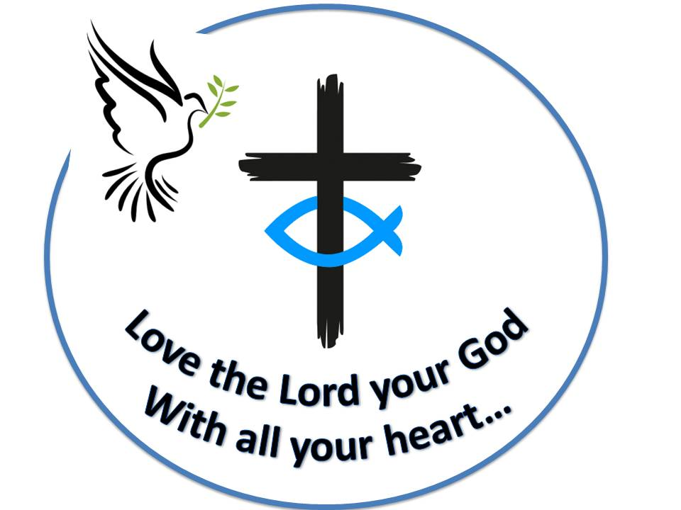 **Westfield URC**

**Weekly Notice Sheet**

**For 24th January 2021**

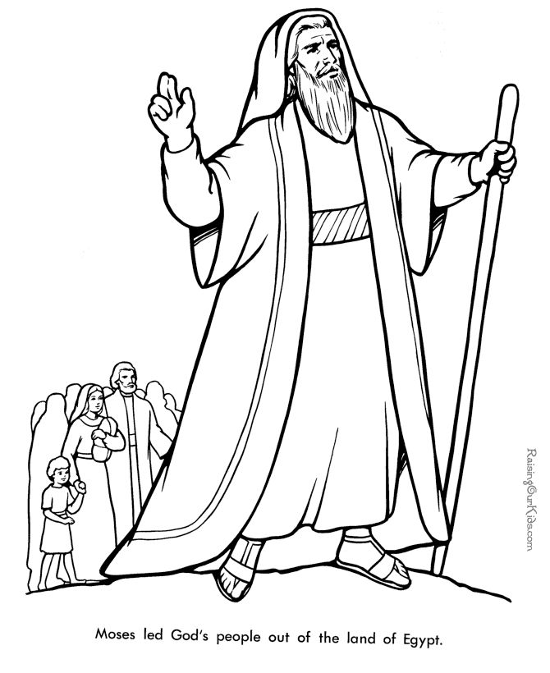

**If you have anything you want to share with the fellowship week by week please email it to Kath by Tuesday evening or ring and we will try to include it on the next weekly sheet.**

**Secretary: Kath Lonsdale: 01274 315203; 07759525936**

[**kathlonsdale@talktalk.net**](mailto:kathlonsdale@talktalk.net)

**Treasurer: Marjorie Hunt: 01274 677115**

**Westfield elders invite you to use the readings, prayers and reflections at 10.30am Sunday morning to help us worship together in Spirit. This week Hilary Chorley shares with us.**

**Update on safety inspections in the Church and Sunday School:**

On 4th & 5th January the electrical safety inspection took place and we have received a certificate for 5 years. All plugged items in both were Pat tested and this lasts for one year.

On 14th January the asbestos safety inspection took place. The report has come and there is no asbestos in Church or in any of the rooms we use in the Sunday School.

On 15th January the gas safety inspection took place.

|  |  |  |  |  |
| --- | --- | --- | --- | --- |
|  |  |  |  |  |

**If you need someone to pray with, a chat or need any help Please ring any elder.**

**I**

**A big thankyou to all who helped on the welcome rota last year.**

For when we can open again:

Could you help by reading the bible passages? **Please let Pauline know.**

Could you help by welcoming people socially distanced near the entrance? **Please let Marjorie know.**

Could you help by being the 2nd person in Shine on a rota? **Please let Kath know.**

**Basil’s memories (27)**

Our tour of Washington D.C continued as we travelled on the trolley, we even saw a look-a-like Abe Lincoln model as part of a peaceful demonstration against the US involvement in the fighting in Iraq. Chinatown occupied a huge area and was on the trolley route. Highly decorative with colourful arches and the inevitable dragons and everything Chinese in there from pagodas to laundresses and obviously peaceful. Unlike many worldwide cities which have rivers flowing through the middle - Prague, London etc - in Washington the river Potomac forms the southern border with the State of Virginia.

We crossed the Arlington Memorial Bridge to the largest and best known area of the city - The Arlington National Cemetery. It really is a sight to behold. Maintained like a bowling green with immaculate tidiness. There are over 250,000 plain white marble crosses marking the majority of the graves, each bearing a US flag on Remembrance Day, other flags are not permitted and anyone who served in the US military, government and their families are entitled to a plot. There are about 24 funerals each week and of course there are major memorials for individuals or groups of prominence, such as the Kennedy family with the ‘eternal flame’ and the amphitheatre surrounding the ‘Tomb of the Unknown’ like our tribute to the ‘Unknown Warrior’ in Westminster Abbey. A place which is very moving for any visitor and certainly worth taking time to visit.

On the way back from the cathedral earlier we had travelled down what the driver called ‘flag avenue’. The road on which every building was a national embassy and consequently flew its own flag. There are about 30 different flags flying there but there are many others in smaller premises all over the city. One very noticeable thing to me was the number of Evangelical Churches, almost on every main street, of all denominations and equipped with domes, towers or spires. Why it is called ‘Washington’ DC? It isn’t a state just a district and separate from all other surrounding states. There is of course a separate state called ‘Washington’ thousands of miles away in the northwest seaboard - the home of The Boeing Aircraft Company in Seattle. So ends an interesting and exciting trip as we returned home. *BPH*

.

*B.P.H.*

Westfield's%20Prayer%20for%20growth.pdf

Noticeboard witness:

For those not walking past church

this week’s poster is

“Fear not for I have redeemed you.

I have called you by name,

You are mine.”

*Isaiah 43:2*

**Westfield URC, Westfield Lane, Wyke, BD12 9DB** [**www.westfieldurc.org**](http://www.westfieldurc.org)**.uk**

**please look at the calendar for future information or ring any elder Marjorie, Pauline, Neil, Glynis or Kath.**