 **Westfield URC**

**Weekly Notice Sheet**

**For 18th April 2021**

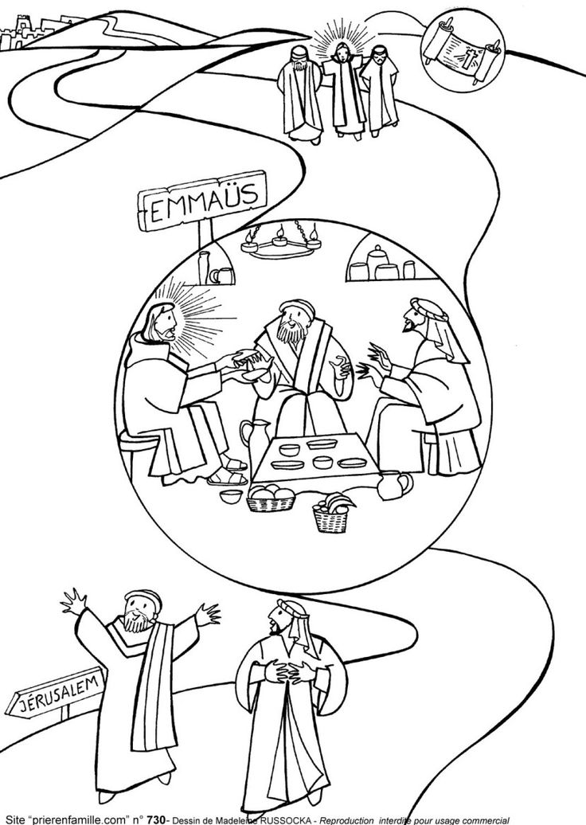

**If you have anything you want to share with the fellowship week by week please email it to Kath by Monday or ring and we will try to include it on the next weekly sheet.**

**Secretary: Kath Lonsdale: 01274 315203; 07759525936**

[**kathlonsdale@talktalk.net**](mailto:kathlonsdale@talktalk.net)

**Treasurer: Marjorie Hunt: 01274 677115**

**Westfield elders invite you to use the readings, prayers and reflections at 10.30am Sunday morning to help us worship together in Spirit. This week Roger Sammons shares the sermon with us.**

|  |  |  |  |  |
| --- | --- | --- | --- | --- |
|  |  | If you need someone to pray with, a chat or need any help please ring any elder. |  |  |

# Please pray for the funeral of Prince Phillip, Duke of Edinburgh on Saturday 17th April at 3pm.

# Eternal God, our rock and our redeemer, we give you thanks and praise for your servant Philip. For all his work and witness. We thank you for his long life, for his dedicated support of his wife in her vocation as Queen, and for his service to commonwealth and nation. We pray for those who will miss him most deeply, that they may find comfort and hope and that their faith may be strengthened by all shared this day. We thank you for the Duke of Edinburgh award, for the work of the World Wide Fund for Nature and for so many causes he inspired and supported. We rejoice that he lived and shared the faith we hold, and that, by your grace, is now with you for eternity. Amen

**Advanced Notices:**

**Prayers 9.30am 23rd May**

**Morning worship 10.30am on 23rd May for Pentecost**

**Robin**

**Prayers 9.30am 30th May**

**Morning worship 10.30am on 30th May for Trinity**

**Rev Jamie Kissack, Yorkshire Moderator**

**Bible Study Tuesday 1st June 7pm & Wednesday 2nd June 2pm - Galatians**

**Building on Basics Bible Study Wednesday 9th June 2pm**

# Basil’s: Some Folk (1)

Some folk have a lot to teach us, but others have nowt worth talking about. The first chap I thought worth talking about is Elijah. He’s said to have had a voice like thunder and his life was full of drama like Shakespeare or Dickens except that Elijah’s experiences were all real. He is almost unique – do you know how? (I’ll tell you at the end of the piece). Most of his eventful life is told in the book of 1st Kings but he got a mention in Malachi and several other mentions in the New Testament. He had no followers, he worked alone and having no impact on the world or the people around him. So much so that he even considered suicide – just once, but God stepped in.

Preparing a portrait of Elijah requires a full palette, a big brush and some dazzling colours. We start by recognising Elijah as a man. Sometimes we are tempted to think of some folk as walking on a higher plane – Moses, David, Daniel or Paul etc. James ch. 5 v 17 says “Elijah was a man just like us. He prayed earnestly etc”, his early life is hidden. God decided that we would gain no spiritual benefit from such information. We have no sense of his age although God was preparing him for service later. Waiting time is not wasting time with God. He prepared Moses for 80 years before he led his people out of Egypt!

The worship of Baal was prevalent (1 Kings 19:18) and very few people were outside the field of idolatry, superstition and evil. It was hard to recognise them as God’s chosen people, when you see the leadership of seven successive wicked kings. Of the first was written “He caused Israel to sin” and the last was the awful Ahab with his even more wicked queen Jezebel. God required Elijah to carry out difficult and dangerous tasks, to say the least and we’ll consider those with ‘Some Folk’ next time. In the meantime what about the nearly unique question? Look at 2 Kings 2:11. He never died. But what makes him ‘nearly’ unique? *BPH*

**If you have any offertory envelopes or donations ready for collection please either deliver them to Marjorie or let Kath know and we will be happy to collect.**

Westfield's%20Prayer%20for%20growth.pdf

Noticeboard witness:

For those not walking past church

this week’s poster is:

“Cast your burden

upon the Lord

and He will sustain you.”

Psalm 55 v22

**Westfield URC, Westfield Lane, Wyke, BD12 9DB** [**www.westfieldurc.org**](http://www.westfieldurc.org)**.uk**

**please look at the calendar for future information or ring any elder Marjorie, Pauline, Neil, Glynis or Kath.**