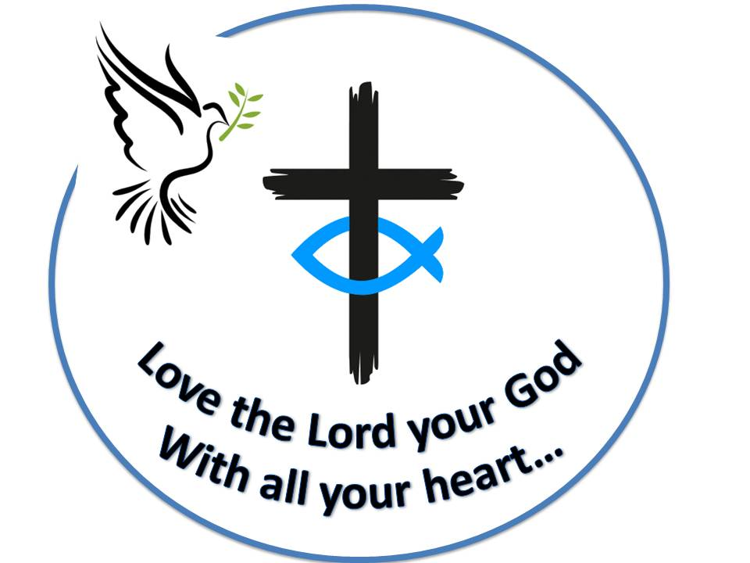 **Westfield URC**

**Weekly Notice Sheet**

**For 2nd May 2021**

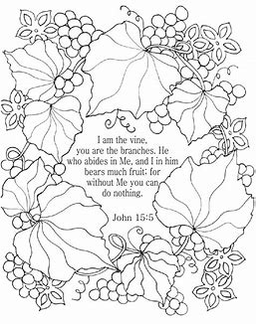

**If you have anything you want to share with the fellowship week by week please email it to Kath by Monday or ring and we will try to include it on the next weekly sheet.**

**Secretary: Kath Lonsdale: 01274 315203; 07759525936**

[**kathlonsdale@talktalk.net**](mailto:kathlonsdale@talktalk.net)

**Treasurer: Marjorie Hunt: 01274 677115**

**Westfield elders invite you to use the readings, prayers and reflections at 10.30am Sunday morning to help us worship together in Spirit. This week Andrew shares with us.**

|  |  |  |  |  |
| --- | --- | --- | --- | --- |
|  |  | If you need someone to pray with, a chat or need any help please ring any elder. |  |  |

**Foodbank challenge from the Wyke foodbank**

**The family of Captain Tom Moore have encouraged people to take on their own 100 challenge on what would have been his birthday weekend 30th April – 2nd May.**

Are you up for the challenge? Can your Church collect 100 items for Wyke foodbank? (Schools have been asked as well)

Here are some suggestions of items you could collect:

Tinned cooked meat Tinned custard Packets of rice Shampoo

Cartons of fruit juice Shower Gel UHT Milk Washing up liquid

Tea Washing powder Coffee Deodorant Tinned tuna

Tinned rice pudding Tinned fruit Sponge puddings

Tinned veg Tinned potatoes

If you are up for helping with this challenge deliver to Kath & Andrew or ask us to pick up from your home.

**Advanced Notices :**

**Prayers 9.30am 23rd May**

**Morning worship 10.30am on 23rd May for Pentecost**

**Robin**

**Prayers 9.30am 30th May**

**Morning worship 10.30am on 30th May for Trinity**

**Rev Jamie Kissack, Yorkshire Moderator**

**Bible Study Tuesday 1st June 7pm & Wednesday 2nd June 2pm - Galatians**

**Building on Basics Bible Study Wednesday 9th June 2pm**

Basil’s: Some Folk (3)

What comes to mind when I say the name ‘Mary’? Some Folk think of two characters, some three or even four, but I have in mind six Mary’s or even seven if you count the Hebrew variation – Miriam. She was Moses’ sister who ‘found’ the baby Moses floating in the reeds (Exodus 1) and brought his mother to be his guardian in the palace for Pharaoh’s daughter - a very clever and cunning manoeuvre by God. She’s the only one in the Old Testament. Mary 2 is Mary the mother of James and Joses (Joseph) who were with Jesus in Galilee and followed Him on the Road of Sorrows, carrying his cross to the site of crucifixion. One of the four Mary’s who were actual witnesses of Jesus’ death and almost certainly the wife of Cleopas on the Emmaus Road as they walked with the resurrected Jesus (John 19:25). Mary 3 is Mary the sister of Martha and Lazarus. She didn’t concern herself with house-keeping like Martha who couldn’t bear to have an untidy house when such an important visitor was expected, even though He was a frequent visitor. Mary met Jesus as He approached and they talked about the resurrection day. The situation was so profound that Jesus wept (John 11:35). Nevertheless, Jesus went to the tomb and called Lazarus back to life. Martha complained to Jesus about Mary’s lack of house-care but was commended for her diligence. It’s even suggested that the sisters were rivals for Jesus’ favour. Mary was the one who had anointed the feet of Jesus in Bethany and followed Him wherever He went right up to the crucifixion. Mary 4 is Mary Magdalene (Luke 8:2) who was caught up with Jesus and the 12 disciples as He preached and healed in Galilee. This Mary was healed of seven demons, sometimes referred to as a ‘fallen woman’. Today we would consider her to be under the influence of drugs. She was the first at the tomb on Easter Sunday although she didn’t recognise the risen Lord until He spoke. Mary 5 is Mary the mother of Jesus. Her story is well known and spoken of regularly especially at Christmas time. Later she had a growing family (James, Joses, Simon and Judas.) There is very little known about Mary although she is ‘blessed amongst women’. It wasn’t until after the resurrection that Mary’s family recognised Jesus as the Son of God. James in fact became the leader of the church in Jerusalem (Archbishop) – (Acts 1:14). The last two are little known but nevertheless have their names for ever in Scripture. They are no.6 – Mary the mother of John Mark (Acts 12:12) and no.7 – a fellow worker for the Gospel, given a special tribute from Paul when he included this Mary in his letter to the Romans (chapter 16 verse 6). *BPH*

**If you have any offertory envelopes or donations ready for collection please either deliver them to Marjorie or let Kath know and we will be happy to collect.**

Westfield's%20Prayer%20for%20growth.pdf

Noticeboard witness:

For those not walking past church

this week’s poster is:

“Cast your burden

upon the Lord

and He will sustain you.”

Psalm 55 v22

**Westfield URC, Westfield Lane, Wyke, BD12 9DB** [**www.westfieldurc.org**](http://www.westfieldurc.org)**.uk**

**please look at the calendar for future information or ring any elder Marjorie, Pauline, Neil, Glynis or Kath.**