 **Westfield URC**

**Weekly Notice Sheet**

**For 30th May 2021**

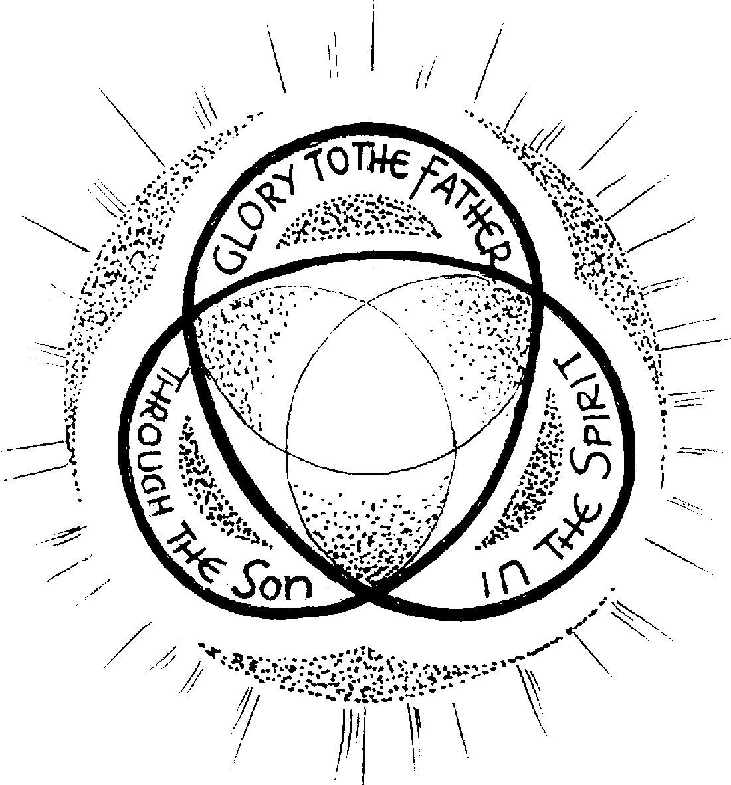

**If you have anything you want to share with the fellowship week by week please email it to Kath by Monday or ring and we will try to include it on the next weekly sheet.**

**Secretary: Kath Lonsdale: 01274 315203; 07759525936**

[**kathlonsdale@talktalk.net**](mailto:kathlonsdale@talktalk.net)

**Treasurer: Marjorie Hunt: 01274 677115**

**Westfield elders invite you to use the readings, prayers and reflections at 10.30am Sunday morning to help us worship together in Spirit whether still at home or back at church. This week Rev Jamie Kissack shares with us.**

Christian Aid Week 10th -16th May: Thankyou for your Christian Aid donations to date this month. Please continue to pray for the use of these vital donations.

|  |  |  |  |  |
| --- | --- | --- | --- | --- |
|  |  |  |  |  |

Update: Adam Woodhouse has a date now for his ordination & induction on Saturday 17th July. Please continue to pray for Adam as he finishes his training and prepares for his first pastorate in Lancashire.

**Today: Sunday 30th May: Prayers 9.30am**

**Morning worship 10.30am**

**Rev Jamie Kissack, Yorkshire Moderator. Duty Elder Neil**

**Advanced Notices:**

**Bible Study Tuesday 1st June 7pm & Wednesday 2nd June 2pm - Galatians**

**First Building on Basics Bible Study led by Andrew**

**Wednesday 9th June 2pm**

**Sunday 4th June Prayers 9.30am**

**Morning Worship 10.30am David Kenyon**

**Evening worship 6.30pm Neil**

**Elders meeting 7th June 6pm Ellis room**

**AGM notification: We will have a short church meeting after the service on Sunday 20th June primarily to receive the 2020 accounts.**

**There will not be group reports but any other necessary agenda items will be notified next week after the elders meeting.**

Basil’s: Some Folk (7)

Some Folk were making a name for themselves thousands of years ago. One such was Joseph 11th son of Jacob (who became Israel). His oldest brothers Reuben, Simeon and Levi already teenagers or beyond when he and Benjamin, (the 12th) were but whippersnappers. What were they all doing and how would Joseph be ‘employed’ as he grew up. There was no school as such - in those days wealth was measured in sheep, goats and camels – the machines of the time providing milk, meat, wool etc, on a big scale, so they would learn from servants the skills of slaughtermen, butchers and so on and would trade with neighbours or passing travellers. Camels were the heavy goods vehicles and donkeys were the light vans or personal transport.

I know that my imagination runs riot when I try to see the whole picture. Somebody must have worked out how to spin the wool and then how to weave it or knit with it. The left over bones would provide the first knitting needles and various pins. At this stage they would no longer be wearing clothes made from leaves and animal skins. Some items would be displayed in the fashions of the day. Joseph was favoured and had a coat of many colours. Who made it? And who was the tailor? Joseph’s brothers hated him especially when he told them about his dreams and that they would all bow to him. Hatred was leading towards murder until the older brother Reuben prevented the act taking place. Twenty shekels of silver was his value to the Midianites, and a blood stained coat was the evidence of Joseph’s death.

The curtain closes on Act 1 and now we find Joseph working as a slave to Potiphar one of the King’s cabinet ministers. He had been well taught about God by his father Israel and so he was used to worshipping in different circumstances. He was a quick learner and a good worker. His master was pleased, unfortunately Potiphar’s wife was a forerunner of Delilah (remember her?) and her terrible lies about Joseph’s conduct led to his shame and imprisonment for about two years – you can read the whole story from Genesis 36 onwards. His true character showed in prison and God didn’t forget him. His fellow prisoners – the King’s former butler and baker looked to Joseph’s God for the interpretation of their dreams. Only one of them survived – the butler, but he forgot about Joseph for two years. Joseph really thought he was doomed until the King celebrated his birthday with a generous release of prisoners. That’s only part 1 of Joseph’s ‘some folk’ and the best (for him) is yet to come. Stay safe on the saddle. The camel has some way to go…

*BPH*

**If you have any offertory envelopes or donations ready for collection please either deliver them to Marjorie or let Kath know and we will be happy to collect.**

Westfield's%20Prayer%20for%20growth.pdf

Noticeboard witness:

For those not walking past church

this week’s poster is:

**“Your word is**

**a lamp to my feet**

**and a light to my path”**

**Psalm 119 v 105**

**Westfield URC, Westfield Lane, Wyke, BD12 9DB** [**www.westfieldurc.org**](http://www.westfieldurc.org)**.uk**

**please look at the calendar for future information or ring any elder Marjorie, Pauline, Neil, Glynis or Kath.**