 **Westfield URC**

**Weekly Notice Sheet**

**For 13th June 2021**

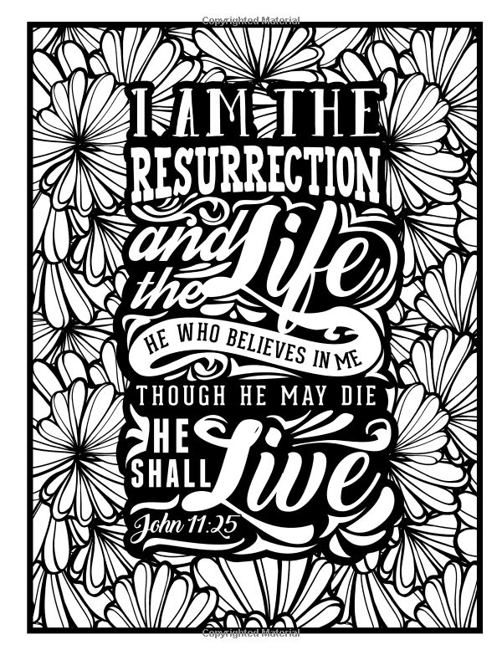

**If you have anything you want to share with the fellowship week by week please email it to Kath by Monday or ring and we will try to include it on the next weekly sheet.**

**Secretary: Kath Lonsdale: 01274 315203; 07759525936**

[**kathlonsdale@talktalk.net**](mailto:kathlonsdale@talktalk.net)

**Treasurer: Marjorie Hunt: 01274 677115**

**Westfield elders invite you to use the readings, prayers and reflections at 10.30am Sunday morning to help us worship together in Spirit whether still at home or back at church. This week Neil & Glynis share with us.**

**Today: Sunday 13th June Prayers 9.30am**

**Morning worship 10.30am Neil & Glynis**

**Duty Elder Neil**

**Monday 14th June Wyke Foodbank steering group meeting 2pm Ellis room**

**Elder’s meeting 6pm Ellis room**

**Bible study Tuesday 15th June 7pm Galatians 2**

**Wednesday 16th June 2pm**

**Sunday 20th June Prayers 9.30am**

**Morning Worship Fathers Day 10.30am Kath & Andrew**

**Duty elder Kath**

**AGM notification: We will have a short church meeting after the service on Sunday 20th June primarily to receive the 2020 accounts.**

**There will not be group reports but may be other necessary agenda items added next week after the elders meeting.**

**Building on basics bible study Wednesday 23rd June 2pm Andrew**

**Wyke Christian Council Committee meeting Wednesday 23rd June 7.30pm at Westfield**

**Sunday 27th June Prayers 9.30am**

**Morning Worship 10.30am John Longbottom**

|  |  |  |  |  |
| --- | --- | --- | --- | --- |
|  |  |  |  |  |

Don’t forget to have a look at the cards for sale if you need any. Proceeds for church funds.

Basil’s: Some Folk (9)

The ‘Some Folk’ story loves to focus on an individual and the events concerning him or her. These are found frequently in the Old Testament. It is not so in the New Testament, where there are only three – Jesus, Paul and at a pinch John. I know there are many characters in the N.T but they mostly appear and disappear in a few verses or sometimes a chapter, John ch. 4 has the story of the Samaritan woman at the well. You’ve read recently about Onesimus – one chapter the book of Philemon. Lydia, the first European Christian, Acts 16 vs 14 & 15, Cornelius in Acts 10 and so on. So the New Testament highlights not just one person but 12 – the Disciples of Jesus. How do you see them? The tendency is to see them like a squad of men marching together with Jesus in front like the changing of the guard at Buckingham Palace. Very wrong! I believe each one was called by Jesus and responded to Him certainly, but 12 different men ranging in age from about 18 to 50 – strangers in most cases. I know that some of them were brothers, two pairs. They all had jobs providing their income – fishmongers, fruit sellers together in the market. Somebody built the boats for the fishermen and the nets. I know this is largely conjecture but they were ordinary men with a very personal sudden calling to be ‘fishers of men’. These are the names in alphabetical order :- Andrew, Bartholomew (also known as Nathaniel), James, James son of Alphaeus, John brother to James, Lebbeus Thadius, Matthew, Philip, Simon Peter brother to Andrew, Simon the Canaanite, Thomas, finally Judas Iscariot the betrayer replaced later by Matthias.

I’m quite sure they were all together on some occasions but not all the time - perhaps at the wedding in Cana where they were all invited and at the feeding of the 5,000 and the 4,000. I think Matthew would have worked mainly alone and he in my view would have been the 50 year old. Philip alone was sent by God to Gaza to help the African eunuch with Isaiah 53. Two went to collect the donkey for Palm Sunday, Simon Peter was the powerful speaker, with others supporting at Pentecost (Acts 2). He must have been empowered by the Holy Spirit - 3,000 were saved that day! - A variety of places with a variety of disciples. Thomas was absent just after the resurrection, but with the rest one week later. John spent his later years on the island of Patmos and to him alone God gave the Revelation of Jesus Christ. What do you think about them? *BPH*

*BPH*

**If you have any offertory envelopes or donations ready for collection please either deliver them to Marjorie or let Kath know and we will be happy to collect.**

Westfield's%20Prayer%20for%20growth.pdf

**Lower Wyke Moravians**

**Scarecrow festival**

**June 19th 10am – 4pm**

**June 20th 12 noon – 4pm**

**Boxed afternoon teas available**

**If you go please take your own chairs to picnic on the Paddock**

**If you pass Westfield over the next weekend you will see our contribution.**

**Westfield URC, Westfield Lane, Wyke, BD12 9DB** [**www.westfieldurc.org**](http://www.westfieldurc.org)**.uk**

**please look at the calendar for future information or ring any elder Marjorie, Pauline, Neil, Glynis or Kath.**