 **Westfield URC**

**Weekly Notice Sheet**

**For 20th June 2021**

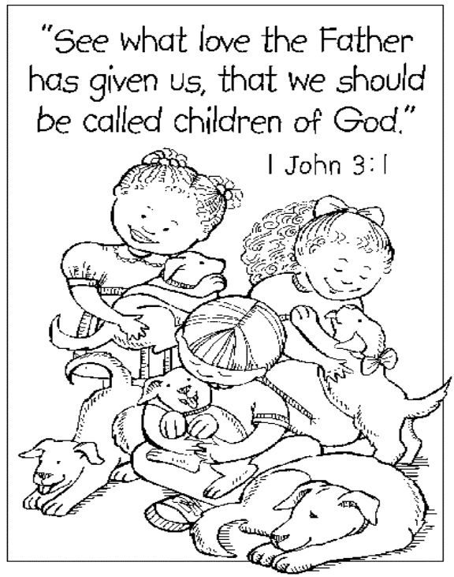

**If you have anything you want to share with the fellowship week by week please email it to Kath by Monday or ring and we will try to include it on the next weekly sheet.**

**Secretary: Kath Lonsdale: 01274 315203; 07759525936**

[**kathlonsdale@talktalk.net**](mailto:kathlonsdale@talktalk.net)

**Treasurer: Marjorie Hunt: 01274 677115**

**Westfield elders invite you to use the readings, prayers and reflections at 10.30am Sunday morning to help us worship together in Spirit whether still at home or back at church. This week Kath & Andrew share with us.**

**Today: Sunday 20th June Prayers 9.30am**

**Morning Worship Fathers Day 10.30am Kath & Andrew Duty elder Kath**

**AGM notification: We will have a short church meeting after the service today primarily to receive the 2020 accounts.**

**Building on basics bible study Wednesday 23rd June 2pm Andrew**

**Wyke Christian Council of Churches meeting Wednesday 23rd June 7.30pm at Westfield**

**Sunday 27th June Prayers 9.30am**

**Morning Worship 10.30am John Longbottom**

|  |  |  |  |  |
| --- | --- | --- | --- | --- |
|  |  |  |  |  |

**Wyke foodbank thankyou:**

**A big thankyou for your support. Everyone working at the foodbank is a volunteer and we are totally reliant on donations from people like you. The challenges of Covid have been the last straw for some – many face bigger bills from being at home, unemployment, domestic abuse, mental health and benefit delays. As well as helping with food we signpost people to a multitude of agencies.**

**“Don’t you know? When you cared for the least of these, my little ones, my true brothers and sisters, you demonstrated love for me.” Matthew 25 v 40.**

*Dawn Stobart, Food bank Manager.*

*There is a longer version of this on the kitchen notice board for you to read.*

**Invitation to Westfield fellowship :**

On behalf of the

North Western Synod of the United Reformed Church,

the Lancashire East Missional Partnership

is inviting you to attend the

**Ordination and Induction**

**of**

**Adam Woodhouse**

on

Sunday July 18th at 2pm

This service will take place at Revidge Fold URC

but will be streamed for all who are invited (Due to current restrictions only those taking part and local church representatives can be there.)

**We discussed this at elders and Andrew will set the link up in the church hall so you can come to watch the service on our screen. We are suggesting we bring a packed lunch and share together socially distanced between the morning service and the ordination. If you want to come and do not want to stay with your lunch please be back by 1.45pm.**

We also decided at elders to continue producing the worship sheets as many of you have shared with one of us that you relook at these during the week. Some of our visitors do not like giving a script beforehand so on those weeks there will only be a notice sheet but when we can we will produce worship sheets for all, whether here on a Sunday or not able to come. Thankyou for the positive feedback.

**If you have any offertory envelopes or donations ready for collection please either deliver them to Marjorie or let Kath know and we will be happy to collect.**

Westfield's%20Prayer%20for%20growth.pdf

Noticeboard witness:

For those not walking past church

this week’s poster is:

**You were no accident.**

**You were not mass produced.**

**You are not assembly line produced.**

**You are deliberately planned,**

**specifically gifted,**

**and lovingly positioned**

**on the earth by the Master craftsman – our God.**

**Westfield URC, Westfield Lane, Wyke, BD12 9DB** [**www.westfieldurc.org**](http://www.westfieldurc.org)**.uk**

**please look at the calendar for future information or ring any elder Marjorie, Pauline, Neil, Glynis or Kath.**