 **Westfield URC**

**Weekly Notice Sheet**

**For 4th July 2021**

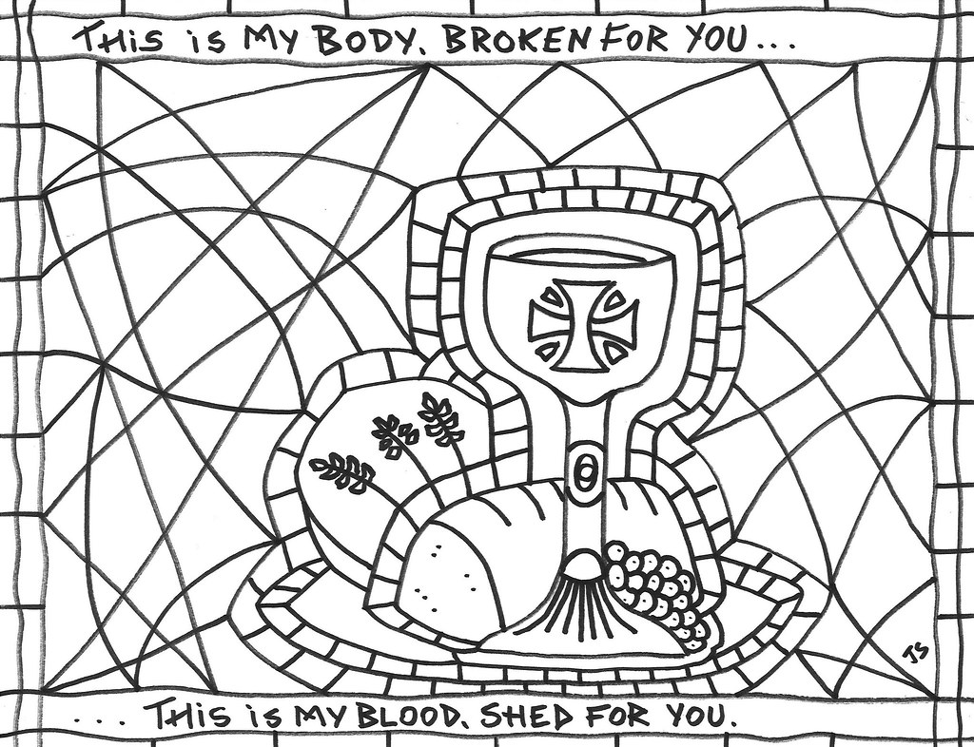

**If you have anything you want to share with the fellowship week by week please email it to Kath by Monday or ring and we will try to include it on the next weekly sheet.**

**Secretary: Kath Lonsdale: 01274 315203; 07759525936**

[**kathlonsdale@talktalk.net**](mailto:kathlonsdale@talktalk.net)

**Treasurer: Marjorie Hunt: 01274 677115**

**Westfield elders invite you to use the readings, prayers and reflections at 10.30am Sunday morning to help us worship together in Spirit whether still at home or back at church. This week Robin shares with us including Communion.**

**Today: Sunday 4th July Prayers 9.30am**

**Morning Worship with communion 10.30am Robin**

**Duty Elder Neil**

**Please note there is no evening service at church but please follow the worship sheet at home.**

**Sunday 11th July Prayers 9.30am**

**Morning worship 10.30am Andrew leading**

**Roger Sammon preaching**

**Duty Elder Glynis**

**Wednesday 14th July Building on Basics 2pm**

**Sunday 18th July Prayers 9.30am**

**Morning Worship 10.30am Christine Milner**

**Please note that the united service at St Mary’s is postponed so we will be at Westfield as usual.**

**1.45pm for 2pm start Adam’s Ordination and Induction on zoom. (if you want to stay after the morning service please bring your own lunch)**

|  |  |  |  |  |
| --- | --- | --- | --- | --- |
|  |  |  |  |  |

**Mission Praise complete hymn books**

If you want to take a Mission Praise hymn book to go through hymns at home please take one from the table on the way out. If you are not back yet and want one dropping off please ask Kath.

**Youth for Christ Daily Devotion**

**“Those who have been ransomed by the LORD will return. They will enter Jerusalem singing, crowned with everlasting joy.” Isaiah 35:10 (NLT)**

Our first car cost £50 and we sold it for the same amount a few years later. Looking back, I wish I had kept what was a unique model which never went into production - it had been built for the 1957 motor show. That story reminds me that each one of us has been specially designed and made. Even though we may consider ourselves to be just one of many, Father God looks on us as unique and precious individuals. He sent His Son to die for us so that we can be released from all the burdens of sin and guilt.   
Remind yourself of Christ’s redeeming love. Remember that whatever you are feeling or going through, you are loved. The reward for your simple faith in Him is a joyous eternity with the Father. Pray for members of your family, that all will know the Father’s love. If you know any families who are distressed because their children have wandered from the faith, pray they will trust that the Father’s plan is to ransom and redeem those who have lost their way. Pray that many families will be filled with joy and gladness as they encounter the living Saviour through our work & witness.

**If you have any offertory envelopes or donations ready for collection please either deliver them to Marjorie or let Kath know and we will be happy to collect.**

Westfield's%20Prayer%20for%20growth.pdf

Noticeboard witness:

For those not walking past church

this week’s poster is:

**You were no accident.**

**You were not mass produced.**

**You are not assembly line produced.**

**You are deliberately planned,**

**specifically gifted,**

**and lovingly positioned**

**on the earth by the Master craftsman – our God.**

**Westfield URC, Westfield Lane, Wyke, BD12 9DB** [**www.westfieldurc.org**](http://www.westfieldurc.org)**.uk**

**please look at the calendar for future information or ring any elder Marjorie, Pauline, Neil, Glynis or Kath.**