 **Westfield URC**

**Weekly Notice Sheet**

**For 11th July 2021**

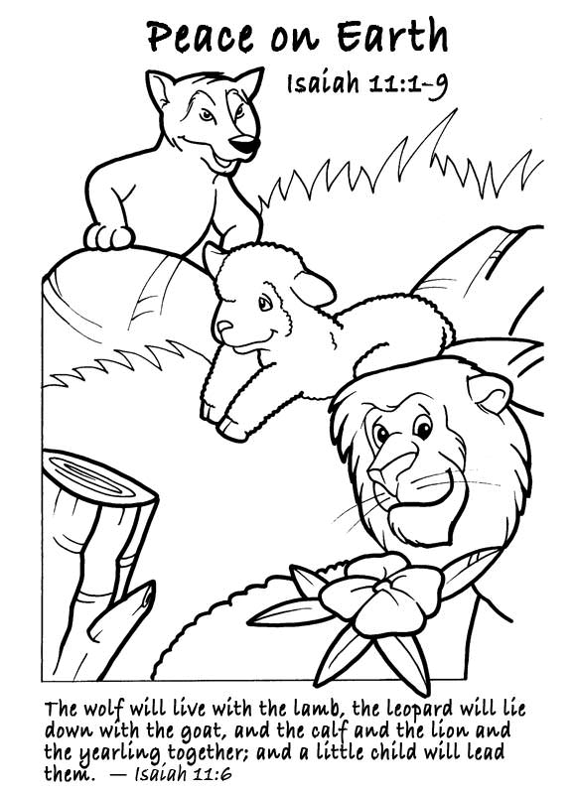

**If you have anything you want to share with the fellowship week by week please email it to Kath by Monday or ring and we will try to include it on the next weekly sheet.**

**Secretary: Kath Lonsdale: 01274 315203; 07759525936**

[**kathlonsdale@talktalk.net**](mailto:kathlonsdale@talktalk.net)

**Treasurer: Marjorie Hunt: 01274 677115**

**Westfield elders invite you to use the readings, prayers and reflections at 10.30am Sunday morning to help us worship together in Spirit whether still at home or back at church. This week Roger Sammons shares with us.**

**Today: Sunday 11th July Prayers 9.30am**

**Morning worship 10.30am Roger Sammons (Andrew)**

**Duty Elder Glynis**

**Wednesday 14th July Building on Basics 2pm**

**Sunday 18th July Prayers 9.30am**

**Morning Worship 10.30am Christine Milner**

**Duty Elder Glynis**

**Please note that the united service at St Mary’s is postponed so we will be at Westfield as usual.**

**1.45pm for 2pm start Adam’s Ordination and Induction on zoom. (if you want to stay after the morning service please bring your own lunch – we will serve tea or coffee at your table)**

**Tuesday 20th July Bible Study 7pm Philippians**

**Repeated Wednesday 21st July 2pm**

**Sunday 25th July Prayers 9.30am**

**Morning Worship 10.30am Graham Mallinson**

**Duty Elder Marjorie**

|  |  |  |  |  |
| --- | --- | --- | --- | --- |
|  |  |  |  |  |

A very happy Birthday Audrey

From your Westfield friends



**Sunday 11th July 10.30am Roger Sammons (Message)**

**(Andrew leading)**

Welcome

Call to worship

Hymn 162 From heaven you came, helpless babe

Prayer and Lord’s Prayer

Notices & Mission Prayer – Glynis

Hymn 790 You are the King of glory

Dedication of offering

Bible Reading Isaiah 11 v 1-12 - Andrew

Message The Rod of Jesse – Roger

Hymn 465 Meekness and majesty

Elders Prayers of Intercession - Glynis

Shine share

Hymn He shall reign by Paul Wilbur

Blessing

Pandemic prayer:

Loving God,  
We live in this waiting time, Wondering what will happen next.   
Asking, questioning, searching. Will we return to the old normal?   
What new things do you have in store for us?  
Creator God, grant us hope in the midst of a confused and troubled world.  
Redeemer God, pour out your gift of love, that our lives may bear fruit.   
Sustainer God, free us from fear about what the future might hold   
and give us power to live whole-heartedly for others and all creation.  
Amen.

**By the Revd Dr Elizabeth Welch, member of St Andrew’s URC in Ealing**

**If you have any offertory envelopes or donations ready for collection please either deliver them to Marjorie or let Kath know and we will be happy to collect.**

Westfield's%20Prayer%20for%20growth.pdf

Noticeboard witness:

For those not walking past church

this week’s poster is:

**You were no accident.**

**You were not mass produced.**

**You are not assembly line produced.**

**You are deliberately planned,**

**specifically gifted,**

**and lovingly positioned**

**on the earth by the Master craftsman – our God.**

**Westfield URC, Westfield Lane, Wyke, BD12 9DB** [**www.westfieldurc.org**](http://www.westfieldurc.org)**.uk**

**please look at the calendar for future information or ring any elder Marjorie, Pauline, Neil, Glynis or Kath.**