 **Westfield URC**

**Weekly Notice Sheet**

**For 18th July 2021**

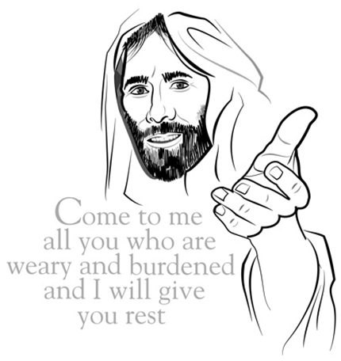

**If you have anything you want to share with the fellowship week by week please email it to Kath by Monday or ring and we will try to include it on the next weekly sheet.**

**Secretary: Kath Lonsdale: 01274 315203; 07759525936**

[**kathlonsdale@talktalk.net**](mailto:kathlonsdale@talktalk.net)

**Treasurer: Marjorie Hunt: 01274 677115**

**Westfield elders invite you to use the readings, prayers and reflections at 10.30am Sunday morning to help us worship together in Spirit whether still at home or back at church. This week Christine Milner shares with us.**

**Today: Sunday 18th July Prayers 9.30am**

**Morning Worship 10.30am Christine Milner**

**Duty Elder Glynis**

**1.45pm for 2pm start Adam’s Ordination and Induction on zoom.**

**Tuesday 20th July Bible Study 7pm Philippians**

**Repeated Wednesday 21st July 2pm**

**Sunday 25th July Prayers 9.30am**

**Morning Worship 10.30am Graham Mallinson**

**Duty Elder Marjorie**

**Refreshments will start to be served again after the service**

**Wednesday 28th July Building on Basics 2pm – Andrew**

**Sunday 1st August Prayers 9.30am**

**Morning Worship including Communion 10.30am**

**Andrew**

|  |  |  |  |  |
| --- | --- | --- | --- | --- |
|  |  |  |  |  |

A very Happy Birthday Betty

From your Westfield friends



**Youth for Christ devotion:**

**God knows how much I love you and long for you with the tender compassion of Christ Jesus. Philippians 1:8 (NLT)**   
It’s lovely to read of Paul’s deep love for the church in Philippi. One of the hallmarks of the fledgling church in those days, which was noticed by non-believers, was how much the Christians loved one other. Living up to what’s described in this verse today is quite a challenge. Let’s bask in the thrill of knowing that the Lord Jesus has a tender and compassionate heart for each of us. As we praise and thank Him for the authenticity of His love, let us be stirred to show that deep love for all fellow believers - even those we may not like.   
We often seem to be embarrassed about praising or thanking someone and yet we find many examples of just that in Paul’s letters. Think about some of the people that you know. When was the last time you affirmed and encouraged them? Could you do that today? Why not send them a text, Bible verse or message of encouragement? Tell them that you are praying for them.

Perhaps you would also think about praying a blessing for Youth for Christ workers. Thank God for each one sharing their faith with young people and families around the country.

**If you have any offertory envelopes or donations ready for collection please either deliver them to Marjorie or let Kath know and we will be happy to collect.**

Westfield's%20Prayer%20for%20growth.pdf

Noticeboard witness:

For those not walking past church

this week’s poster is:

**You were no accident.**

**You were not mass produced.**

**You are not assembly line produced.**

**You are deliberately planned,**

**specifically gifted,**

**and lovingly positioned**

**on the earth by the Master craftsman – our God.**

**Westfield URC, Westfield Lane, Wyke, BD12 9DB** [**www.westfieldurc.org**](http://www.westfieldurc.org)**.uk**

**please look at the calendar for future information or ring any elder Marjorie, Pauline, Neil, Glynis or Kath.**