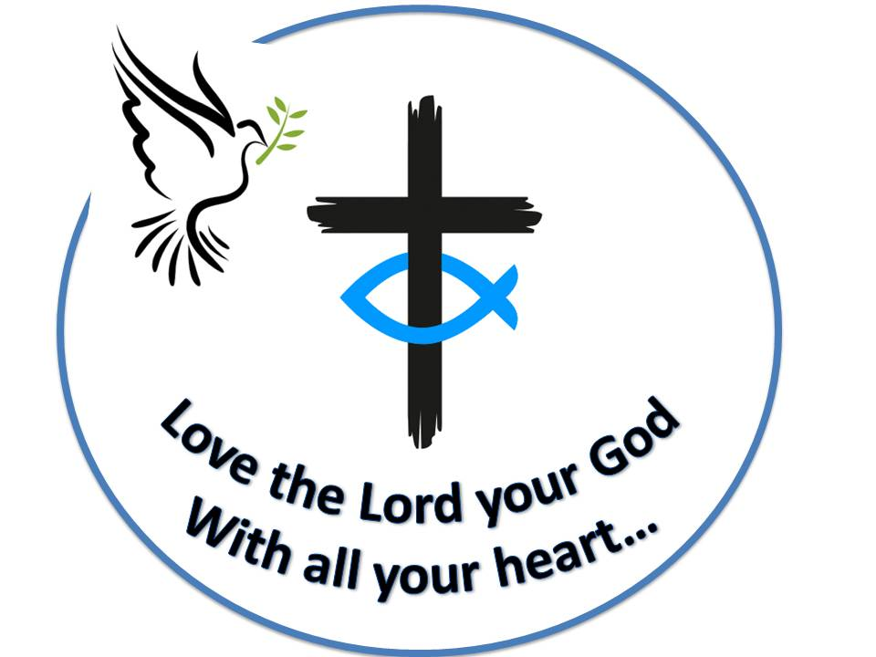 **Westfield URC**

**Weekly Notice Sheet**

**For 5th September 2021**

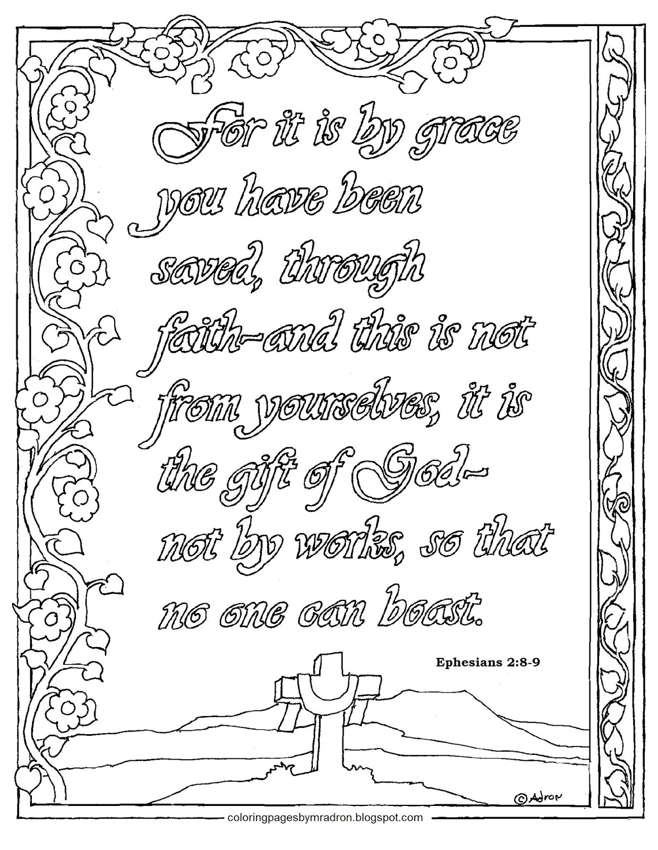

**If you have anything you want to share with the fellowship week by week please email it to Kath by Monday or ring and we will try to include it on the next weekly sheet.**

**Secretary: Kath Lonsdale: 01274 315203; 07759525936**

[**kathlonsdale@talktalk.net**](mailto:kathlonsdale@talktalk.net)

**Treasurer: Marjorie Hunt: 01274 677115**

**Westfield elders invite you to use the readings,**

**prayers and reflections at 10.30am Sunday morning to help us worship together in Spirit whether still at home or back at church. This week Robin shares with us.**

**Today: Sunday 5th September Prayers 9.30am**

**Morning worship with communion 10.30am Robin**

**Duty Elder Marjorie**

**Please note that there will be no evening service at church. Please follow your paper copy at home.**

**Please use the monthly prayer sheet alongside your daily prayers – Thankyou Neil for faithfully sending us both the evening service notes and the monthly prayer notes each month.**

**Please pray for the Wyke Christian Council of Churches meeting Wednesday 8th September 7.30pm at Westfield.**

**Sunday 12th September Prayers 9.30am**

**Morning worship 10.30am John Wilson**

**Duty Elder Glynis**

**Items to Marjorie for the next newsletter by 12th September please**

**Bible Study Tuesday 14th September 7pm Colossians**

**Wednesday 15th September 2pm Thessalonians part 1**

**Sunday 19th September Prayers 9.30am**

**Morning worship 10.30am John Longbottom**

**Duty Elder Neil**

**Building on Basics Bible study Wednesday 22nd September 2pm**

|  |  |  |  |  |
| --- | --- | --- | --- | --- |
|  |  |  |  |  |

**A very Happy Birthday**

**Pauline ( A )**

**From your Westfield friends**



**Youth for Christ Devotion:**

**He came into the very world he created, but the world didn’t recognize him. He came to his own people, and even they rejected him. But to all who believed him and accepted him, he gave the right to become children of God. They are reborn - not with a physical birth resulting from human passion or plan, but a birth that comes from God. John 1:10-13 (NLT)** One of the good things about the lockdowns has been the realisation that the world as we have previously known it has changed. Similarly, as God’s people, we need to grasp hold of the dynamic change God brought when He sent Jesus to be born in a stable. Having the right to become children of God must surely be the most breath-taking event that can ever happen to us. Looking back, I’m humbled that God chose me to be born again and the thought spurs me on to share that good news with others.   
  
Think about your journey of faith. It may be that you have found Jesus recently, followed Him for many years or perhaps you are still searching. These words of John remind us that it is not how good we are, whether we are educated, rich, poor, abused, broken or doing well for ourselves – it is only through God’s grace and mercy that we can be born again. Pray that as all Christians including Youth for Christ workers faithfully proclaim the gospel, their words and actions will glorify God and bring hope to people of all ages who have not heard the amazing news about Jesus.

Westfield's%20Prayer%20for%20growth.pdf

Noticeboard witness: For those not walking past church this week’s poster is:

**“Here I am!**

**I stand at the door and knock.**

**If anyone hears my voice**

**and opens the door,**

**I will come in**

**and eat with that person,**

**and they with me, says the Lord.”**

**Revelation 3 v 20**

**Westfield URC, Westfield Lane, Wyke, BD12 9DB** [**www.westfieldurc.org**](http://www.westfieldurc.org)**.uk**

**please look at the calendar for future information or ring any elder Marjorie, Pauline, Neil, Glynis or Kath.**