 **Westfield URC**

**Weekly Notice Sheet**

**For 26th June 2022**

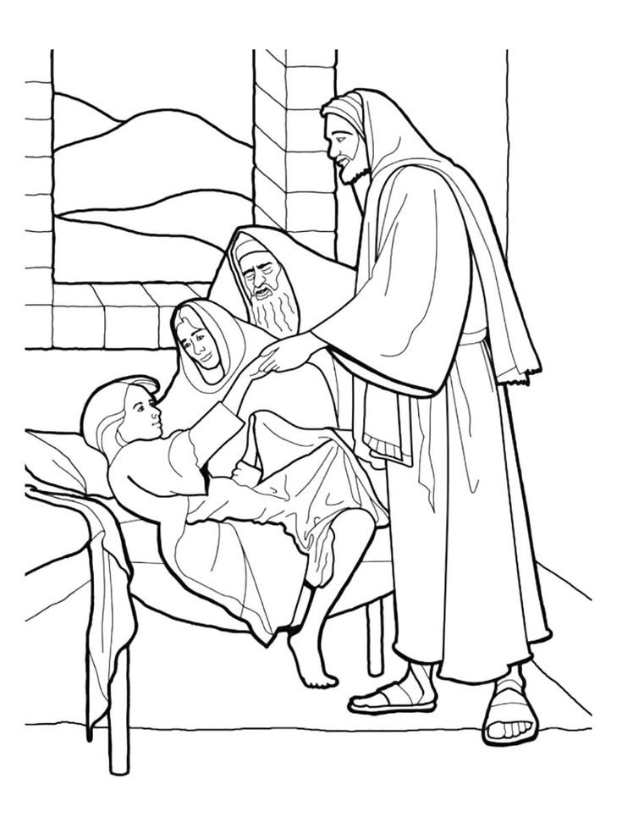

**If you have anything you want to share with the fellowship week by week please email it to Kath by Monday or ring and we will try to include it on the next weekly sheet.**

**Secretary: Kath Lonsdale: 01274 315203; 07759525936**

[**kathlonsdale@talktalk.net**](mailto:kathlonsdale@talktalk.net)

**Treasurer: Marjorie Hunt: 01274 677115**

**This week John shares with us**

Today Sunday 26th June Prayers 9.30am

Morning service 10.30am John

MP 18 All over the world

MP 178 Go forth and tell - tune 631(i)

OT Reading 2 Samuel Ch1 v 17-27

MP 465 Majesty, Worship His Majesty

NT Reading Mark Ch5 v 21 - 43

MP 31 Amazing Grace

MP 746 What a friend we have in Jesus

MP 543 Onward Christian Soldiers

Duty Elder Pauline

Building on Basics Wednesday 29th June 2pm

Andrew

Rainbows, Brownies, Guides and Rangers Thursday 30th June 6pm -9pm

Sunday 3rd July Prayers 9.30am

Morning Service with communion 10.30am

Robin

Evening service 3rd July 6.30pm Neil

**Advanced notice: United service 17th July 10.30am at Wyke Methodists –**

**Andrew preaching**

**No service at Westfield on this day –**

**please support the United service if you can.**

**Please ask if you need transport.**

|  |  |  |  |  |
| --- | --- | --- | --- | --- |
|  |  |  |  |  |

**13th June Elders meeting decision**

There will be a short church meeting on 31st July after the service to share the recommendations from the elders to accept the church accounts for 2021 and the election of elders.

Our friends at the Moravians have the following events that we are invited to:

Strawberry afternoon tea

2pm Saturday 2nd July

Proms in the Paddock

Gates open 6pm Saturday 9th July

Concert starts 7pm

Bring your own chair, food & drink.

Wyke Churches Prayers are at the Moravians 9.15am Saturday 2nd July.

**Happy Birthday Annette (H)**

**from your Westfield friends**



God of Mission,

Who alone brings growth to your Church,

Send your Holy Spirit to give

Vision to our planning,

Wisdom to our actions,

And power to our witness.

Help our church to grow in numbers,

In spiritual commitment to you,

And in service to our local community,

And to increase in love and unity within the fellowship (modified from LYCIG prayer)

Lord of all, as you walked this earth

Sharing love, grace and mercy,

We pray that we will place our footsteps in yours

And walk where you lead

As we live out your life in our daily living.

Through Jesus Christ our Lord, Amen (Walking the Way prayer)

Noticeboard witness: For those not walking past church this week’s poster is:

You were not an accident.

You were not mass produced.

You are not assembly line produced.

You are deliberately planned,

specifically gifted,

and lovingly positioned on the earth

by the Master craftsman – our God.

**Westfield URC, Westfield Lane, Wyke, BD12 9DB** [**www.westfieldurc.org**](http://www.westfieldurc.org)**.uk**

**please look at the calendar for future information or ring any elder Marjorie, Pauline, Neil, Glynis or Kath.**