 **Westfield URC**

**Weekly Notice Sheet**

**For 3rd July 2022**

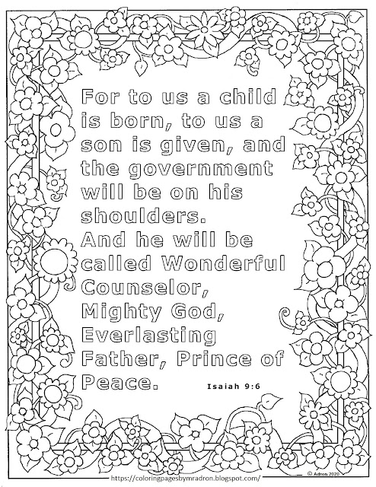

**If you have anything you want to share with the fellowship week by week please email it to Kath by Monday or ring and we will try to include it on the next weekly sheet.**

**Secretary: Kath Lonsdale: 01274 315203; 07759525936**

[**kathlonsdale@talktalk.net**](mailto:kathlonsdale@talktalk.net)

**Treasurer: Marjorie Hunt: 01274 677115**

Today Sunday 3rd July Prayers 9.30am

Morning service with communion

10.30am Robin

MP 41 At the name of Jesus

OT Reading Isaiah 9 v 2-7

NT Reading Matthew 1 v 18-27

MP 367 Jesus is Lord

MP 251 How sweet the name of Jesus sounds

MP 431 Lord enthroned (tune 147)

Duty Elder Glynis

Communion Elders Glynis & Neil

Evening service 6.30pm Neil

Monday 4th July Wyke Foodbank

Steering Group 2pm Ellis Room

Wednesday 6th July Wyke Christian Council of

Churches 7.30pm at Westfield

Please pray for decision making at both these meetings and for guidance for the representatives there.

Rainbows, Brownies, Guides and Rangers Thursday 7th July 6pm -9pm

Sunday 10th July Prayers 9.30am

Morning Service 10.30am Roger Sammons

Duty elder Neil

|  |  |  |  |  |
| --- | --- | --- | --- | --- |
|  |  |  |  |  |

Tuesday 12th July 7pm Bible Study

1 & 2 Peter part 2

Wednesday 13th July 2pm Bible Study

1 & 2 Peter part 2

Wednesday 27th July 2pm Bible Study

Building on Basics

Our friends at the Moravians have the following event that we are invited to:

Proms in the Paddock

Gates open 6pm Saturday 9th July

Concert starts 7pm

Please bring your own chair, food & drink.

**Advanced notice: United service 17th July 10.30am at Wyke Methodists –**

**Andrew preaching**

**No service at Westfield on this day –**

**please support the United service if you can.**

**Please ask if you need transport.**

There will be a short church meeting on

31st July after the service to consider the recommendations from the elders regarding the church accounts for 2021 and the election of elders.

God of Mission,

Who alone brings growth to your Church,

Send your Holy Spirit to give

Vision to our planning,

Wisdom to our actions,

And power to our witness.

Help our church to grow in numbers,

In spiritual commitment to you,

And in service to our local community,

And to increase in love and unity within the fellowship (modified from LYCIG prayer)

Lord of all, as you walked this earth

Sharing love, grace and mercy,

We pray that we will place our footsteps in yours

And walk where you lead

As we live out your life in our daily living.

Through Jesus Christ our Lord, Amen (Walking the Way prayer)

Noticeboard witness: For those not walking past church this week’s poster is:

You were not an accident.

You were not mass produced.

You are not assembly line produced.

You are deliberately planned,

specifically gifted,

and lovingly positioned on the earth

by the Master craftsman – our God.

**Westfield URC, Westfield Lane, Wyke, BD12 9DB** [**www.westfieldurc.org**](http://www.westfieldurc.org)**.uk**

**please look at the calendar for future information or ring any elder Marjorie, Pauline, Neil, Glynis or Kath.**